How AI Works

AI Made Easy for Decision Makers

December, 2023

Table of Contents

# About this Course

This is the series of courses in Fred Hutch DaSL’s “AI for Decision Makers” specialization on Coursera.

## 0.1 Specialization Sections

* Introduction
* Course 1: AI Possibilities
* Course 2: Avoiding AI Harm
* Course 3: Establishing AI Infrastructure
* Course 4: AI Policy

## 0.2 Available course formats

This course is available in multiple formats which allows you to take it in the way that best suites your needs. You can take it for certificate which can be for free or fee.

* The material for this course can be viewed without login requirement on this [Bookdown website](LINK%20HERE). This format might be most appropriate for you if you rely on screen-reader technology.
* This course can be taken for [free certification through Leanpub](LINK%20HERE).
* This course can be taken on [Coursera for certification here](LINK%20HERE) (but it is not available for free on Coursera).
* Our courses are open source, you can find the [source material for this course on GitHub](LINK%20HERE).

# 1 VIDEO Summary of This Course

# 2 Introduction

## 2.1 Motivation

How can understanding AI help you be a better leader?



We think understanding AI is essential for executives. It helps today’s leaders make strategic decisions, drive innovation, enhance efficiency, and foster a culture that embraces the transformative power of these technologies. Specifically, AI proficiency can help leaders in the following ways:

1. **Strategic Decision-Making:** Understanding AI and machine learning equips leaders to make informed decisions about integrating these technologies into business strategies, setting their teams up for success when working with AI.
2. **Risk Mitigation:** Familiarity with AI helps leaders assess risks associated with implementing these technologies, ensuring that ethical considerations, data privacy, and potential biases are addressed to mitigate negative consequences. Leaders can also implement more informed policies for their teams.
3. **Efficiency and Experience:** Leaders can explore how AI applications enhance operational efficiency, automate repetitive tasks, and assist employee learning and development, leading to increased productivity and breakthroughs. These improvements can also improve the experience of users or customers your organization serves.
4. **Resource Allocation:** AI resources can be expensive, including in terms of computing resources, subscription services, and/or personnel time. Understanding AI enables leaders to allocate resources effectively, whether in building in-house AI capabilities, partnering with external experts, or investing in AI-driven solutions that align with the organization’s mission.
5. **Innovation Leadership:** Leaders can foster a culture of innovation by understanding the transformative potential of AI. Awareness and knowledge can also enable leaders to identify opportunities for innovation, helping their teams match the rapidly evolving technological landscape.
6. **Data-Driven Decision Culture:** Leaders can promote a data-driven decision-making culture within their organizations, using AI insights to inform strategic planning, understand their teams better, and improve other key business functions.
7. **Communication with Tech Teams:** Executives and managers benefit from understanding AI event if they aren’t building tech, as it helps them effectively communicate with their technical teams. This can mean more effective collaboration and improved alignment between teams or departments.

## 2.2 Target Audience

This specialization is intended for executives, decision-makers, and business leaders across industries, including executives in C-suite positions, managers, and directors. Our goal is for these learners to understand the strategic applications of AI and machine learning in driving innovation, improving operations, creating supportive working environments, and gaining an innovative edge.

We also believe that learning is a life-long process. This specialization is targeted toward those who value continuous learning and want to stay ahead in today’s fast-paced technology landscape.



## 2.3 Curriculum

The course covers…

# 3 Introduction to AI Possibilities

## 3.1 Introduction

This course aims to help decision makers and leaders understand artificial intelligence (AI) at a strategic level. Not everyone will write an AI algorithm, and that is okay! Our rapidly evolving AI landscape means that we need executives and managers who know the essential information to make informed decisions and use AI for good. This course specifically focuses on the essentials of what AI is and what it makes possible, to better harmonize expectations and reality in the workplace.

### 3.1.1 Motivation

This course will help you with your understanding of AI, helping you make strategic decision and cultivate a business environment that embraces the benefits of AI, while understanding its limitations and risks.

### 3.1.2 Target Audience

This course is targeted toward industry and non-profit leaders and decision makers.

### 3.1.3 Curriculum Summary

In this course, we’ll learn about what Artificial intelligence is, and what it isn’t. We’ll also learn the basics of how it works, learn about different types of AI, and set some ground rules for minimizing the harms and maximizing the benefits of AI.

### 3.1.4 Learning Objectives

# 4 VIDEO What Is AI

TODO: Slides here: <https://docs.google.com/presentation/d/1-Mm-Vym3xdtB8xLRHR24jNCLSbNgFHw6N62iJrYe63c/edit#slide=id.g2a162964683_1_0>

# 5 What Is AI

When discussing artificial intelligence, people often envision humanoid robots, prompting concerns about their ability to outsmart us. The notion of robots passing tests that blur the line between human and machine, often depicted in science fiction, adds to these worries, particularly when considering the potential for AI systems to act in self-interest and make decisions independently.

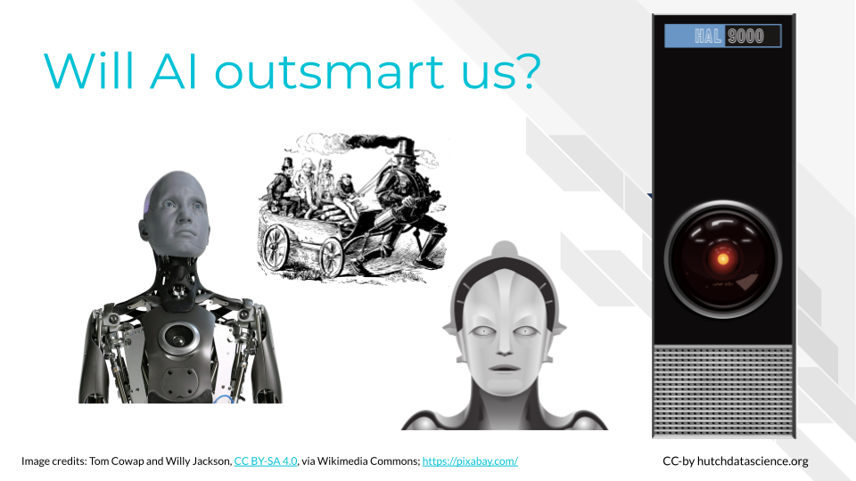

Defining what AI is can be tricky because what experts consider to be AI changes frequently. John McCarthy, one of the leading early figures in AI once said, “As soon as it works, no one calls it artificial intelligence anymore”.

For instance, 20 years ago, the idea of an email spam checker was new. People were surprised that an algorithm could identify junk email accurately, and called it “artificial intelligence”. Since this type of algorithm has become so common, it is no longer called “artificial intelligence”. This transition happened because we no longer think it is surprising that computers can filter spam messages. Because it is not learning something new and surprising, it is no longer considered intelligent.

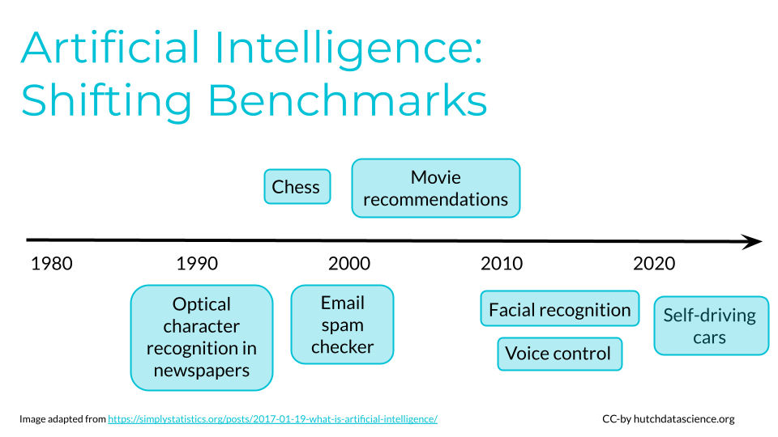

We often look at human intelligence the same way. For example, many years ago, only a few people knew how to use the internet. These people might have been considered extremely talented and intelligent. Now, the massive growth of online resources and social media mean that fluent internet use is almost required!

Scientists are still working toward computers with full human problem solving and cognition, or **artificial general intelligence**. We aren’t there yet. Currently, artificial intelligence systems are optimized to perform a specific task well, but not for general, multi-purpose tasks. For example, the AI application for recognizing voices can not be directly applied to drive cars, and vice versa. Similarly, a language translation app could not recognize images, and vice versa.

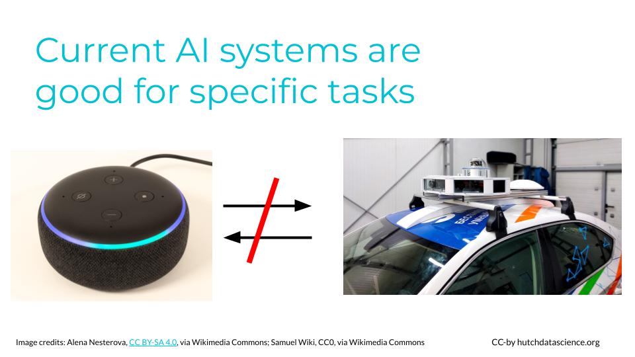

**Artificial General Intelligence (AGI)**: A type of artificial intelligence that can understand, learn, and apply knowledge across a wide range of tasks, similar to the broad cognitive abilities of a human being. It represents the aspiration for machines to have versatile intelligence rather than focusing on specific, narrow domains. Check out **Types of AI** to learn more.

## 5.1 Our AI Definition

Going forward in this course, we define AI as having the following features:

1. **Dataset**: AI needs data examples that can be used to train a statistical or machine learning model to make predictions.
2. **Algorithm**: AI needs an algorithm, or a set of procedures, that can be trained based on the data examples. That way, it can take a new example and execute a human-like task. For instance, the algorithm learns which images feature a cat from pre-labeled images. When given a new image, it decides whether the image has a cat in it.
3. **Interface**: AI needs a physical interface or software for the trained algorithm to receive a data input and execute the human-like task in the real world. For example, you might interface with a chatbot in your web browser.



## 5.2 AI In Practice

The following are case studies that can help us conceptualize AI in the real world.

### 5.2.1 Amazon Recommendations

Amazon’s recommendation engine uses AI algorithms to analyze user behavior and past purchases, providing personalized product recommendations. This enhances the shopping experience, increases customer engagement, and drives sales.

TODO: Text here.

### 5.2.2 Financial Forecasting

In this case study, we will look at how artificial intelligence has been utilized in governmental financial services. National banks, such as the Federal Reserve of United States and the European Central bank of the European Union, have started to explore how Artificial Intelligence can be used for data mining and economic forecast prediction.

There are many uses of AI for improving financial institutions, each with potential benefits and risks. Most financial institutions weigh the benefits and risks carefully before implementation.

For instance, if a financial institution takes a high-risk prediction seriously, such as predicting a financial crisis or a large recession, then it would have huge impact on a bank’s policy and allows the bank to act early. However, many financial institutions are hesitant to take action based on artificial intelligence predictions because the prediction is for a high-risk situation. If the prediction is not accurate then there can be severe consequences. Additionally, data on rare events such as financial crises are not abundant, so researchers worry that there is not enough data to train accurate models (Nelson 2023).

Many banks prefer to pilot AI for low-risk, repeated predictions, in which the events are common and there is a lot of data to train the model on.

Let’s look at a few examples that illustrate the potential benefits and risks of artificial intelligence for improving financial institutions.

#### 5.2.2.1 Categorizing Businesses



An important task in analysis of economic data is to classify business by institutional sector. For instance, given 10 million legal entities in the European Union, they need to be classified by financial sector to conduct downstream analysis. In the past, classifying legal entities was curated by expert knowledge (Moufakkir 2023).

Text-based analysis and machine learning classifiers, which are all considered AI models, help reduce this manual curation time. An AI model would extract important keywords and classify into an appropriate financial sector, such as “non-profits”, “small business”, or “government”. This would be a low-risk use of AI, as one could easily validate the result to the true financial sector.

#### 5.2.2.2 Incorporating new predictors for forecasting



Banks are considering expanding upon existing traditional economic models to bring in a wider data sources, such as pulling in social media feeds as an indicator of public sentiment. The National bank of France has started to use social media information to estimate the public perception of inflation. The Malaysian national bank has started to incorporate new articles into its financial model of gross domestic product estimation. However, the use of these new data sources may may raise questions about government oversight of social media and public domain information (OMFIF 2023).

#### 5.2.2.3 Using Large Language Models to predict inflation



The US Federal Reserve has researched the idea of using pre-trained large language models from Google to make inflation predictions. Usually, inflation is predicted from the Survey of Professional Forecasters, which pools forecasts from a range of financial forecasts and experts. When compared to the true inflation rate, the researchers found that the large language models performed slightly better than the Survey of Professional Forecasters (Federal Reserve Bank of St. Louis 2023).

A concern of using pre-trained large language models is that the data sources used for model training are not known, so the financial institution may be using data that is not in line with its policy. Also, a potential risk of using large language models that perform similarly is the convergence of predictions. If large language models make very similar predictions, banks would act similarly and make similar policies, which may lead to financial instability (OMFIF 2023).

## 5.3 What Is and Is Not AI

Let’s look at a few of examples. We can then decide whether or not the examples constitute AI.

### 5.3.1 Smartphones



The name “smartphone” implies these devices are making decisions and are powered by AI. Let’s consider our three criteria:

1. **Dataset:** Smartphones do collect a lot of data. For example, they retain your text messages and collect motion tracking information.
2. **Algorithm:** The smartphone as a whole does not usually get trained with this data. However, some features like virtual voice assistants and facial recognition do adapt given your data.
3. **Interface**: Again, some features like voice assistants can be interacted with through the smartphone.

While there are some features on smartphones that are powered by AI models, like virtual voice assistants and facial recognition, the device as a whole isn’t considered AI.

### 5.3.2 Calculators



Many of us use basic calculators, as you might find in Microsoft Excel, every day. AI also makes many calculations. Is it just a scaled-up calculator?

1. **Dataset:** Calculators and spreadsheets can store data.
2. **Algorithm:** Calculators do not generally use this data to train algorithms. The procedures that are performed (addition, subtraction, etc.) are almost always predefined. However, some AI-powered assistants are starting to be integrated into software like Excel and Google Sheets.
3. **Interface**: Calculators do meet the criteria for an interface, whether through a physical device or software application.

Traditional calculators are not considered AI, because they can only execute predefined operations.

### 5.3.3 Computer Programs



Like calculators, computers follow set procedures for problem solving and computation. Everyday computers use these procedures to help automate repetitive tasks and save time. However, this isn’t generally considered AI, because the computer’s algorithms aren’t being trained with new data you supply. AI systems exhibit the ability to adapt and handle new inputs for tasks that might be more complicated.

### 5.3.4 DISCUSSION Is It AI

Consider the following examples. Are they examples of AI? Why or why not? Click to expand and see the answer.

**A smartfridge that lets you know when replacement parts are needed**

This is not AI. The computer in the fridge is typically programmed to look for specific signs of wear or time passing. It is not typically trained with new data.

**Speed cameras on the highway**

Speed cameras on highways typically use specialized technology and are not explicitly powered by AI. These cameras are often equipped with radar sensors for measuring vehicle speed between checkpoints.

While the core functionality of speed cameras relies on sensor technology and predetermined speed thresholds, AI elements may be incorporated in some advanced systems. For example, AI could be used to enhance image recognition accuracy for reading license plates. However, the fundamental operation of speed cameras is rooted in sensor-based speed detection, not AI.

**Suggested accounts on Instagram**

This is considered AI. Social media algorithms, like Instagram’s, make recommendations based on user behavior. For example, if you spend a lot of time viewing a page that was recommended, the system interprets that as positive feedback and will make similar recommendations. Typically, these recommendations get better over time as the user generates more user-specific data. You supply data through your behaviors, the algorithm gets trained, and you interact with the suggestions via the app.

## 5.4 Summary

The definition of artificial intelligence (AI) has shifted over time. We use the three part framework of data, algorithms, and interfaces to describe AI applications. You will need to consider specific technologies and whether they meet the criteria for being classified as AI using this framework. Adaptability and training with new data are key factors to keep in mind as we move further in the course.

# 6 VIDEO How AI Works

TODO: Slides here: <https://docs.google.com/presentation/d/1OydUyEv1uEzn8ONPznxH1mGd4VHC9n88_aUGqkHJX4I/edit#slide=id.g263e06ef889_36_397>

# 7 How AI Works

Let’s briefly revisit our definition of AI: it must have data, algorithm(s), and an interface. Let’s dive into each of these in more detail below.

## 7.1 Early Warning for Skin Cancer

Each year in the United States, 6.1 million adults are treated for skin cancer (basal cell and squamous cell carcinomas), totaling nearly $10 billion in costs (CDC 2023). It is one of the most common forms of cancer in the United States, and mortality from skin cancer is a real concern. Fortunately, early detection through regular screening can increase survival rates to over 95% (Melarkode et al. 2023). Cost and accessibility of screening providers, however, means that many people aren’t getting the preventative care they need.

Increasingly, AI is being used to flag potential skin cancer. AI focused on skin cancer detection could be used by would-be patients to motivate them to seek a professional opinion, or by clinicians to validate their findings or help with continuous learning.

1. **Data**: Images of skin
2. **Algorithm**: Detection of possible skin cancer
3. **Interface**: Web portal or app where you can submit a new picture

## 7.2 Collecting Datapoints

Let’s say a clinician, *Dr. Derma*, is learning how to screen for skin cancer. When Dr. D sees their first instance of skin cancer, they now have one data point. Dr. D could make future diagnoses based on this one data point, but it might not be very accurate. Over time, as Dr. D does more screenings of skin with and without cancer, they will get a better and better idea of what skin cancer looks like. This is part of what we do best. Human beings are powerhouses when it comes to pattern recognition and processing (Mattson 2014).

Like Dr. D, AI will get better at finding the right patterns with more data. In order to train an AI algorithm to detect possible skin cancer, we’ll first want to gather as many pictures of normal and cancerous skin as we can. This is the **raw data** (Leek and Narayanan 2017).

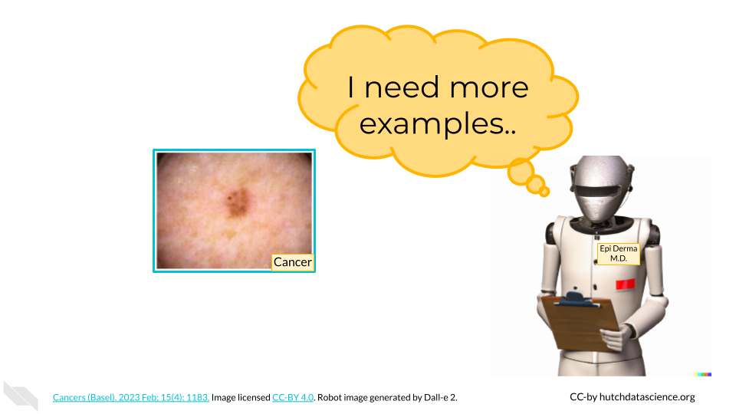

### 7.2.1 What Is Data

In our skin cancer screening example, our data is all of the information stored in an image. However, data comes in many shapes and forms. Data can be **structured**, such as a spreadsheet of the time of day plus traffic volume or counts of viral particles in different patients. Data can also be **unstructured**, such as might be found in social media text or genome sequence data.

Other kinds of data can be collected and used to train algorithms. These might include survey data collected directly from consumers, medical data collected in a healthcare setting, purchase or transaction tracking, and online tracking of your time on certain web pages (Cote 2022).

Quantity *and* quality of data are very important. More data makes it easier to detect and account for minor differences among observations. However, that shouldn’t come at the cost of quality. It is sometimes better to have fewer, high resolution or high quality images in our dataset than many images that are blurry, discolored, or in other ways questionable.

Representative diversity of datasets is crucial for the effectiveness of AI. For instance, if an AI used for skin cancer screening only encounters instances of skin cancer on lighter skin tones, it might fail to alert individuals with darker skin tones.

The tech industry’s lack of diversity contributes to these issues, often leading to the discovery of failures only after harm has occurred.

Large Language Models (LLMs), which we will cover later, are great examples of high quantity and quality of data. Think about how much text information is freely available on the internet! Throughout the internet, we’re much more likely to see the phrase “cancer is a disease” than “cancer is a computer program”. Many LLMs are trained on sources like [Wikipedia](https://www.wikipedia.org/), which are typically grammatically sound and informative, leading to higher quality output.



It is **essential** that you and your team think critically about data sources. Many companies releasing generative AI systems have come under fire for training these systems on data that doesn’t belong to them (Walsh 2023). Individual people also have a right to data privacy. No personal data should be used without permission, even if that data could be interesting or useful.

### 7.2.2 Preparing the Data

It’s important to remember that AI systems need specific instructions to start detecting patterns. We’ll need to take our raw data and indicate which pictures are positive for skin cancer and which aren’t. This process is called **labeling** and has to be done by humans.

Once data is labeled, either “cancer” or “not cancer”, we can use it to train the algorithm in the next step. This data is aptly called **training data**.

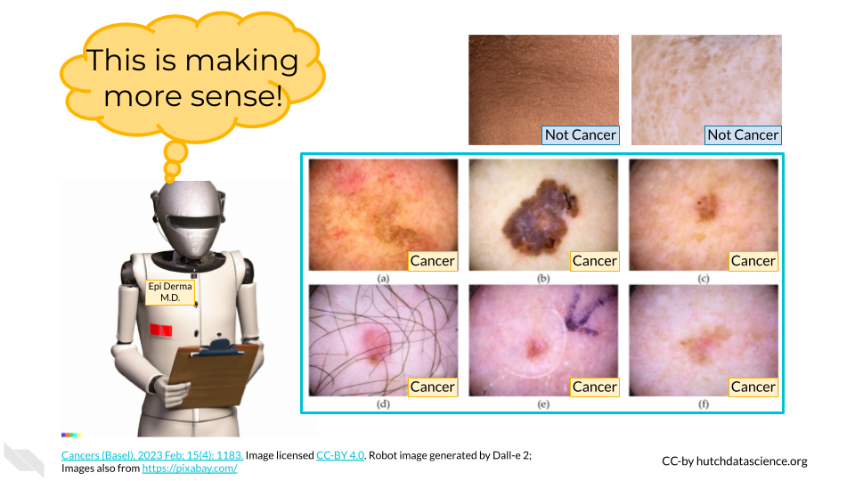

## 7.3 Understanding the Algorithm

Our goal is “detection of possible skin cancer”, but how does a computer do that?

First, we’ll need to break down the image into attributes called **features**. This could be the presence of certain color pixels, percentage of certain shades, spot perimeter regularity, or other features. Features can be determined by computers or by data scientists who know what kind of features are important. It’s not uncommon for an AI looking at image data to have thousands of features.

Because we’ve supplied a bunch of images with labels, AI can look for patterns that are present in cancerous images that are not present in others.

As an example, here is a very simple algorithm with one feature (spot perimeter):

1. Calculate the perimeter of a darker spot in the image.
2. If the perimeter of the spot is exactly circular, label the image “not cancer”.
3. If the perimeter of the spot is not circular, label the image “cancer”.

### 7.3.1 Testing the Algorithm

After setting up and quantifying the features, we want to make sure the AI is actually doing a good job. We’ll take some images the AI hasn’t seen before, called **test data**. We know the correct answers, but the AI does not. The AI will measure the features within each of the images to provide an educated guess of the proper label. Every time AI gets a label wrong, it will reassess parts of the algorithm. For example, it might make the tweak below:

1. Calculate the perimeter of a darker spot in the image.
2. If the perimeter of the spot is close to circular, label the image “not cancer”.
3. If the perimeter of the spot is not close to circular, label the image “cancer”.

Humans play a big part in what kind of scores are acceptable when producing outputs. With cancer screening, we might be very worried about missing a real instance of cancer. Therefore, we might tell the AI to score false negatives more harshly than false positives.

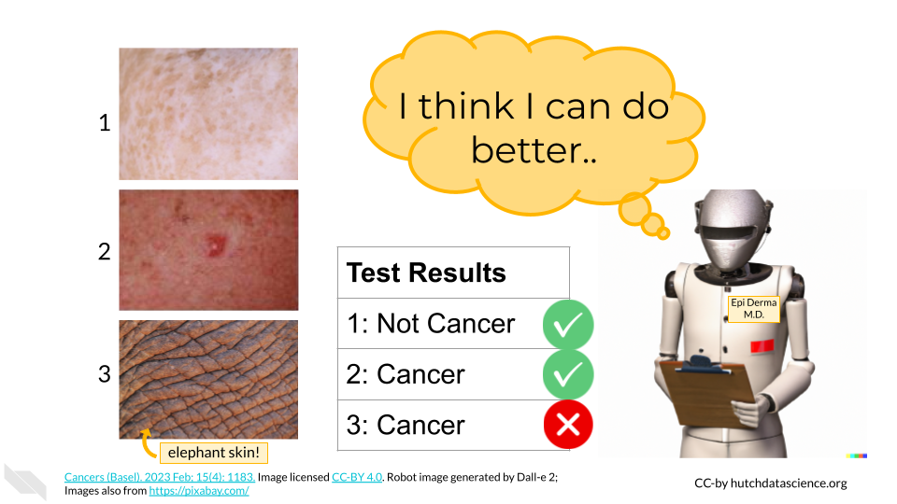

## 7.4 Interfacing with AI

Finally, AI would not work without an interface. This is where we can get creative. In our skin cancer screening, we might create a website where providers or patients could upload a picture of an area that needs screening.

* Because skin images could be considered medical data, we would need to think critically about what happens to images after they are uploaded. Are images deleted after a screening prognosis is made? Will images be used to update the training data?
* Telling people they might have cancer could be very upsetting for them. Our interface should provide supporting resources and clear disclaimers about its abilities.

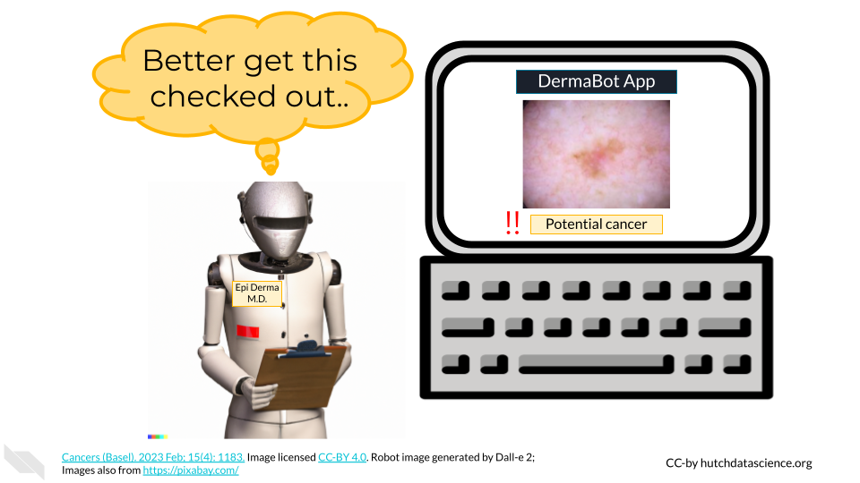

# 8 VIDEO Different Types of AI

# 9 Demystifying Types of AI

We’ve learned a bit about how AI works. However there are many different types of AI with different combinations of data, algorithms, and interfaces. There are also general terms that are important to know. Let’s explore some of these below.

## 9.1 Machine Learning

**Machine learning** is broad concept describing how computers to learn from data. It includes traditional methods like decision trees and linear regression, as well as more modern approaches such as deep learning. It involves training models on labeled data to make predictions or uncover patterns or grouping of data. Machine learning is often the “algorithm” part of our data - algorithm - interface framework.

## 9.2 Neural Networks

**Neural networks** are a specific class of algorithms within the broader field of machine learning. They organize data into layers, including an input layer for data input and an output layer for results, with intermediate “hidden” layers in between.

You can think of layers like different teams in an organization. The input layer is in charge of scoping and strategy, the output layer is in charge of finalizing deliverables, while the intermediate layers are responsible for piecing together existing and creating new project materials. These layers help neural networks understand hierarchical patterns in data.

The connections between nodes have weights that the network learns during training. The network can then adjust these weights to minimize errors in predictions. Neural networks often require large amounts of labeled data for training, and their performance may continue to improve with more data.

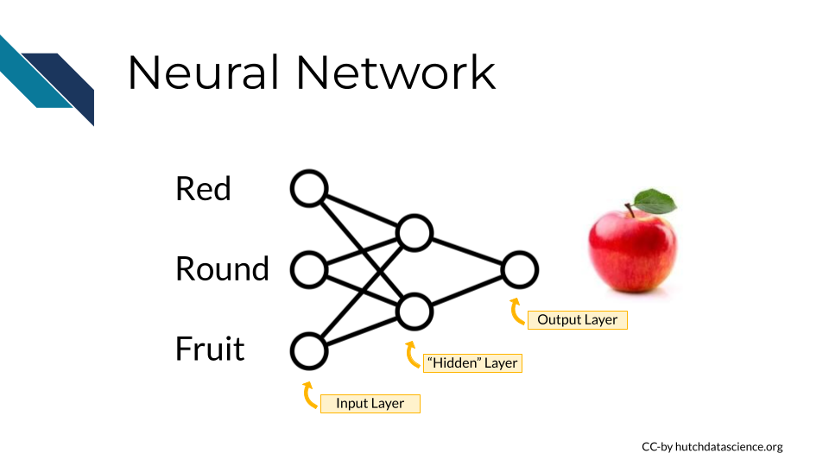

# 10 VIDEO Real Life Possibilities

What type of AI for specific possibilities - case studies

# 11 What Is Possible

What is possible with AI? What’s still fantasy?

# 12 VIDEO What Is Possible

# 13 VIDEO What Is NOT Possible

# 14 Ground Rules for AI

Ground rules - don’t do bad things with AI!

# 15 VIDEO Knowing the Ground Rules

# 16 Introduction to Avoiding AI Harm

This course aims to help you recognize some of the potential consequences of using or developing AI tools.

Some of this content was adapted from our course on [AI for Efficient Programming](https://hutchdatascience.org/AI_for_Efficient_Programming/ethics-of-using-ai.html). If you intend to use AI for writing code, we recommend that you review this content for a deeper dive into ethics specifically for writing code with generative AI.

## 16.1 Motivation

The use of artificial intelligence (AI) and in particular, generative AI, has raised a number of ethical concerns. We will highlight several current concerns, however please be aware that this is a dynamic field and the possible implications of this technology is continuing to develop. It is critical that society continue to evaluate and predict what the consequences of the use of AI will be, so that we can try to mitigate harmful effects.



## 16.2 Target Audience

This course is intended for leaders who might make decisions about AI at nonprofits, in industry, or academia.

## 16.3 Curriculum

This course provides a brief introduction about ethical concepts to be aware of when making decisions about AI, as well as **real-world examples** of situations that involved ethical challenges.

The course will cover:

* Possible societal impacts of AI
* Concerns to be aware of for AI algorithms
* Strategies to adhere to AI codes of ethics
* Concepts for consent with AI
* IDARE principles (Inclusion, Diversity, Anti-Racism, and Equity) with AI
* A proposed process for ethical AI use and development

## 16.4 Learning Objectives

We will demonstrate how to:

* Describe key ethical concerns for using AI tools
* Identify possible mitigation strategies for these major concerns
* Explain the potential benefits of being transparent about the use of AI tools
* Discuss why human contributions are still important and necessary
* Explain a possible process for reflecting on ethical AI use and development

# 17 Societal Impact

There is the potential for AI to dramatically influence society. It is our responsibility to be proactive in thinking about what uses and impacts we consider to be useful and appropriate and those we consider harmful and inappropriate.

## 17.1 Ethics Codes

There are a few current major codes of ethics for AI:

* United States [Blueprint for an AI Bill of Rights](https://www.whitehouse.gov/ostp/ai-bill-of-rights/)
* United States [Executive Order on the Safe, Secure, and Trustworthy Development and Use of Artificial Intelligence](https://www.whitehouse.gov/briefing-room/presidential-actions/2023/10/30/executive-order-on-the-safe-secure-and-trustworthy-development-and-use-of-artificial-intelligence/)
* European Commission [Ethics Guidelines for trustworthy AI](https://digital-strategy.ec.europa.eu/en/library/ethics-guidelines-trustworthy-ai)
* The Institute of Electrical and Electronics Engineers (IEEE) [Ethically Aligned Design Version 2](https://standards.ieee.org/wp-content/uploads/import/documents/other/ead_v2.pdf)

As this is an emerging technology, more codes will be developed and updated as the technology evolves. When you read this, more codes and updates are likely to be available.

## 17.2 Major Ethical Considerations

In this chapter we will discuss the some of the major ethical considerations in terms of possible societal consequences for the use or development of AI tools:

1. **Intentional and Inadvertent Harm** - Data and technology intended to serve one purpose may be reused by others for unintended purposes. How do we prevent intentional harm?
2. **Replacing Humans and Human autonomy** - AI tools can help humans, but they are not a replacement. Humans are still much better at generalizing their knowledge to other contexts and human oversight is required (Sinz et al. (2019)).
3. **Inappropriate Use** - There are situations in which using AI might not be appropriate now or in the future.
4. **Bias Perpetuation and Disparities** - AI models are built on data and code that were created by biased humans, thus bias can be further perpetuated by using AI tools. In some cases Bias can even be exaggerated. This combined with differences in access may exacerbate disparities.
5. **Security and Privacy Issues** - Data for AI systems should be collected in an ethical manner that is mindful of the rights of the individuals the data comes from. Data around usage of those tools should also be collected in an ethical manner. Commercial tool usage with proprietary or private data, code, text, images or other files may result in leaked data not only to the developers of the commercial tool, but potentially also to other users.
6. **Climate Impact** - As we continue to use more and more data and computing power, we need to be ever more mindful of how we generate the electricity to store and perform our computations.
7. **Transparency** - Being transparent about what AI tools you use where possible, helps others to better understand how you made decisions or created any content that was derived by AI, as well as the possible sources that the AI tools might have used when helping you. It may also help with future unknown issues related to the use of these tools.

Keep in mind that some fields, organizations, and societies have guidelines or requirements for using AI, like for example the policy for the use of large language models for the [International Society for Computational Biology](https://www.iscb.org/iscb-policy-statements/iscb-policy-for-acceptable-use-of-large-language-models). Be aware of the requirements/guidelines for your field.

Note that this is an incomplete list; additional ethical concerns will become apparent as we continue to use these new technologies. We highly suggest that users of these tools be **careful to learn more about the specific tools they are interested in** and to be **transparent** about the use of these tools, so that as new ethical issues emerge, we will be better prepared to understand the implications.

## 17.3 Intentional and Inadvertent Harm

AI tools need to be developed with safeguards and continually audited to ensure that the AI system is not responsive to harmful requests by users. With additional usage and updates, AI tools can adapt and thus continual auditing is required.

Of course using AI to help you perform a harmful action would result in intentional harm. This may sound like an obvious and easy issue to avoid, at least by those with good intent. However, the consequences may be much further reaching than might be first anticipated.

Perhaps you or your company develop an AI tool that helps to identify individuals that might especially benefit from a product or service that you offer. This in and of itself is likely not harmful. However, the data you have used, the data that you may have collected, and the tool that you have created, all could be used for other malicious reasons, such as targeting specific groups of people for advertisements when they are vulnerable.

Therefore it is critical that we be considerate of the downstream consequences of what we create and what might happen if that technology or data was used for other purposes.

### 17.3.1 Tips for avoiding inadvertent harm

* Consider how the content, data, or newly developed AI tool might be used by others.
* Continually audit any new AI tools.

## 17.4 Replacing Humans and Human Autonomy

While AI systems are useful, they **do not replace human strengths**. Humans remain far superior at generalizing concepts to new contexts (Sinz et al. (2019)).

Computer science is a field that has historically lacked diversity. It is critical that we support diverse new learners of computer science, as we will continue to need human involvement in the development and use of AI tools. This can help to ensure that more diverse perspectives are accounted for in our understanding of how these tools should be used responsibly.

### 17.4.1 Tips for supporting human contributions

* Avoid thinking that content by AI tools must be better than that created by humans, as this is not true (Sinz et al. (2019)).
* Recall that humans wrote the code to create these AI tools and that the data used to train these AI tools also came from humans. Many of the large commercial AI tools were trained on websites and other content from the internet.
* Be transparent where possible about when you do or do not use AI tools, give credit to the humans involved as much as possible.

A new term in the medical field called [AI paternalism](https://www.technologyreview.com/2023/04/21/1071921/ai-is-infiltrating-health-care-we-shouldnt-let-it-make-decisions/) describes the concept that doctors (and others) may trust AI over their own judgment or the experiences of the patients they treat. This has already been shown to be a problem with earlier AI systems intended to help distinguish patient groups. Not all humans will necessarily fit the expectations of the AI model if it is not very good at predicting edge cases (Hamzelou n.d.). Therefore, in all fields it is important for us to not forget our value as humans in our understanding of the world.

## 17.5 Inappropriate Use

There are situations in which we may, as a society, not want an automated response. There may even be situations in which we do not want to bias our own human judgment by that of an AI system. There may be other situations where the efficiency of AI may also be considered inappropriate. While many of these topics are still under debate and AI technology continues to improve, we challenge the readers to consider such cases given what is currently possible and what may be possible in the future.

Some reasons why AI may not be appropriate for certain situation include:

* Despite the common misconception that AI systems have clearer judgment than humans, they are in fact typically just as prone to bias and sometimes even exacerbate bias (Pethig and Kroenung (2023)). There are some very mindful researchers working on these issues in specific contexts and making progress where AI may actually improve on human judgment, but generally speaking AI systems are currently typically biased and reflective of human judgment but in a more limited manner based on the context in which they have been trained.
* AI systems can behave in unexpected ways (Gichoya et al. (2022)).
* Humans are still better than AI at generalizing what they learn for new contexts.
* Humans can better understand the consequences of discussions from a humanity standpoint.

Some examples where it may be considered inappropriate for AI systems to be used include:

* In the justice system to determine if someone is guilty of a crime or to determine the punishment of someone found guilty of a crime.
* It may be considered inappropriate for AI systems to be used in certain warfare circumstances.

### 17.5.1 Tips for avoiding inappropriate uses

* Stay up-to-date on current practices and standards for your field, as well as up-to-date on the news for how others have experienced their use of AI.
* Stay involved in discussions about appropriate uses for AI, particularly for policy.
* Begin using AI slowly and iteratively to allow time to determine the appropriateness of the use. Some issues will only be discovered after some experience.
* Involve a diverse group of individuals in discussions of intended uses to better account for a variety of perspectives.
* Seek outside expert opinion whenever you are unsure about your AI use plans.
* Consider AI alternatives if something doesn’t feel right.

## 17.6 Bias Perpetuation and Disparities

One of the biggest concerns is the potential for AI to further perpetuate bias. AI systems are trained on data created by humans. If this data used to train the system is biased (and this includes existing code that may be written in a biased manner), the resulting content from the AI tools could also be biased. This could lead to discrimination, abuse, or neglect for certain groups of people, such as those with certain ethnic or cultural backgrounds, genders, ages, sexuality, capabilities, religions or other group affiliations.

It is well known that data and code are often biased (Belenguer 2022). The resulting output of AI tools should be evaluated for bias and modified where needed. Please be aware that because bias is intrinsic, it may be difficult to identify issues. Therefore, people with specialized training to recognize bias should be consulted. It is also vital that evaluations be made throughout the software development process of new AI tools to check for and consider potential perpetuation of bias.

Because of differences in access to technology, disparities may be further exacerbated by the usage of AI tools. Consideration and support for under-served populations will be even more necessary. For example tools that only work well on individuals with light skin, will lead to further challenges to some individuals.

Developing and scaling-up artificial intelligence-based innovations for use in low- and middle-income countries will thus require deliberate efforts to generate locally representative training data (Paul and Schaefer (2020)).

In the flip side, AI has the potential if used wisely, to reduce health inequities by potentially enabling the scaling and access to expertise not yet available in some locations.

### 17.6.1 Tips for avoiding bias

* Be aware of the biases in the data that is used to train AI systems.
* Check for possible biases within data used to train new AI tools.
  + Are there harmful data values? Examples could include discriminatory and false associations.
  + Are the data adequately inclusive? Examples could include a lack of data about certain ethnic or gender groups or disabled individuals, which could result in code that does not adequately consider these groups, ignores them all together, or makes false associations.
  + Are the data of high enough quality? Examples could include data that is false about certain individuals.
* Evaluate the code for new AI tools for biases as it is developed. Check if any of the criteria for weighting certain data values over others are rooted in bias.
* Consider the possible outcomes of the use of content created by AI tools. Consider if the content could possibly be used in a manner that will result in discrimination.

See Belenguer (2022) for more guidance. We also encourage you to check out the following video for a classic example of bias in AI:

For further details check out this [course](https://www.coursera.org/learn/algorithmic-fairness) on Coursera about building fair algorithms. We will also describe more in the next section.

## 17.7 Security and Privacy issues

Security and privacy are a major concern for AI usage. Here we discuss a few aspects related to this.

### 17.7.1 Use the right tool for the job

There are two kinds of commercial AI tools (Nigro (2023)):

* those that are designed for public general use
* those that are designed private use with sensitive data

Public commercial AI tools are often **not designed to protect users from unknowingly submitting prompts that include propriety are private information**. Different AI tools have different practices in terms of how they do or do not collect data about the prompts that people submit. They also have different practices in terms of if they reuse information from prompts to other users. Note that the AI system itself may not be trained on responses for how prompt data is collected or not. So asking the AI system may not give accurate answers.

Thus if users of public AI tools, such as ChatGPT submit prompts that include propriety or private information, they **run the risk of that information being viewable not only by the developers/maintainers of the AI tool used, but also by other users** who use that same AI tool.

### 17.7.2 AI can have security blind spots

Furthermore, AI tools are not always trained in a way that is particularly conscious of data security. If for example, code is written using these tools by users who are less familiar with coding security concerns, protected data or important passwords may be leaked within the code itself. AI systems may also utilize data that was actually intended to be private.

### 17.7.3 Data source issues

It is also important to consider what data the responses that you get from a commercial AI tool might actually be using. Are these datasets from people who consented to their data being used in this manner? If you are generating your own tools, did people consent for their data to be used as you intend?

Data privacy is a major issue all on it’s own:

98% of Americans still feel they should have more control over the sharing of their data (Pearce (2021))

It is important to follow legal and ethical guidance around the collection of data and to use tools that also abide by these guidelines.

### 17.7.4 Tips for reducing security and privacy issues

* Check that no sensitive data, such as Personal Identifiable Information (PII) or propriety information becomes public through prompts to commercial AI systems.
* Consider purchasing a license for a private AI system if needed or create your own if you wish to work with sensitive data (seek expert guidance to determine if the AI systems are secure enough).
* Promote for regulation of AI tools by voting for standards where possible.
* Ask AI tools for help with security when using commercial tools, but to not rely on them alone. In some cases, commercial AI tools will even provide little guidance about who developed the tool and what data it was trained on, regardless of what happens to the prompts and if they are collected and maintained in a secure way.
* Consult with an expert about data security if you want to design or use a AI tool that will regularly use private or propriety data.
* Development of new tools should involve

Are there any possible data security or privacy issues associated with the plan you proposed?

## 17.8 Climate Impact

The data storage and computing resources needed for AI could exacerbate climate challenges (Bender et al. (2021)).

## 17.9 Tips for reducing climate impact

* Thoughtful planning to efficiently modify existing models as opposed to unnecessarily creating new models from scratch is needed.
* Solutions such as [federated learning](https://research.ibm.com/blog/what-is-federated-learning), where AI models are iteratively trained in multiple locations using data at those locations, instead of collectively sharing the data to create more massive datasets can help [reduce](https://www.cam.ac.uk/research/news/can-federated-learning-save-the-world.) the required resources and also help preserve data privacy and security.
* Avoid using models with datasets that unnecessarily large (Bender et al. (2021))

## 17.10 Transparency

In the United States Blueprint for the AI Bill of Rights, it states:

You should know that an automated system is being used and understand how and why it contributes to outcomes that impact you.

This transparency is important for people to understand how decisions are made using AI, which can be especially vital to allow people to contest decisions.

It also better helps us to understand what AI systems may need to be fixed or adapted if there are issues.

### 17.10.1 Tips for being transparent in your use of AI

* Where possible include the AI tool and version that you may be using and why so people can trace back where decisions or content came from
* Providing information about what training data was or methods used to develop new AI models can help people to better understand why it is working in a particular

## 17.11 Summary

Here is a summary of all the tips we suggested:

* Be mindful of how content created with AI or AI tools may be used for unintended purposes.
* Be aware that humans are still better at generalizing concepts to other contexts (Sinz et al. (2019)).
* Always have expert humans review content created by AI and value human contributions and thoughts.
* Carefully consider if an AI solution is appropriate for your context.
* Be aware that AI systems are biased and their responses are likely biased. Any content generated by an AI system should be evaluated for potential bias.
* Be aware that AI systems may behave in unexpected ways. Implement new AI solutions slowly to account for the unexpected. Test those systems and try to better understand how they work in different contexts.
* Be aware of the security and privacy concerns for AI, be sure to use the right tool for the job and train those at your institute appropriately.
* Consider the climate impact of your AI usage and proceed in a manner makes efficient use of resources.
* Be transparent about your use of AI.

Overall, we hope that awareness of these concerns and the tips we shared will help us all use AI tools more responsibly. We recognize however, that as this is emerging technology and more ethical issues will emerge as we continue to use these tools in new ways. Staying up-to-date on the current ethical considerations will also help us all continue to use AI responsibly.

# 18 Algorithm considerations

In this chapter we will discuss the some of the major ethical considerations regarding the algorithms underlying AI tools. We will provide some tips for how to deal with these issues that may be useful for creating AI guidelines at your institution.

1. **Toxic Responses** - Currently it is not clear how well generative AI models restrict harmful responses in terms of ideas, code, text, etc.
2. **Lack of Interpretability** - When complicated algorithms are used within AI systems, it can be unclear how it came up with a decision. In many circumstances it is necessary to understand how the AI system works to know how to proceed.
3. **Misinformation and Faulty Responses** - Fake or manipulated data used to help design algorithms could be believed to be correct and this could be further propagated. Text, code, etc. provided to users may not be correct or optimal for a given situation, and may have at times severe downstream consequences.

Note that this is an incomplete list; additional ethical concerns will become apparent as we continue to use these new technologies. We highly suggest that users of these tools **careful to learn more about the specific tools they are interested in** and to be **transparent** about the use of these tools, so that as new ethical issues emerge, we will be better prepared to understand the implications.

## 18.1 Harmful or Toxic Responses

One major concern is the use of AI to generate malicious content. Secondly the AI itself may accidentally create harmful responses or suggestions. For instance, AI could start suggesting the creation of code that spreads malware or hacks into computer systems. Another issue is what is called [“toxicity”](https://towardsdatascience.com/toxicity-in-ai-text-generation-9e9d9646e68f), which refers to disrespectful, rude, or hateful responses (Nikulski (2021)). These responses can have very negative consequences for users. Ultimately these issues could cause severe damage to individuals and organizations, including data breaches and financial losses. AI systems need to be designed with safeguards to avoid harmful responses, to test for such responses, and to ensure that the system is not infiltrated by additional possibly harmful parties.

### 18.1.1 Tips for avoiding the creation of harmful content

* Be careful about what commercial tools you employ, they should be transparent about what they do to avoid harm.
* If designing a system, ensure that best practices are employed to avoid harmful responses. This should be done during the design process and should the system should also be regularly evaluated. Some development systems such as [Amazon Bedrock](https://aws.amazon.com/blogs/aws/evaluate-compare-and-select-the-best-foundation-models-for-your-use-case-in-amazon-bedrock-preview/) have tools for evaluating [toxicity](https://towardsdatascience.com/toxicity-in-ai-text-generation-9e9d9646e68f) to test for harmful responses. Although such systems can be helpful to automatically test, evaluation should also be done directly by humans.
* Be careful about the context in which you might have people use AI - will they know how to use it responsibly?
* Be careful about what content you share publicly, as it could be used for malicious purposes.
* Consider how the content might be used by others.
* Ask the AI tools to help you, but do not rely on them alone.

What are the possible downstream uses of this content?

What are some possible negative consequences of using this content?

## 18.2 Lack of Interpretability

There is risk in using AI tools, that we may encounter situations where it is unclear why the AI system came to a particular result. AI systems that use more complicated algorithms can make it difficult to trace back the decision process of the algorithm.

Using content created or modified by AI, could make it difficult for others to understand if the content is adequate or appropriate, or to identify and fix any issues that may arise.

This could result in negative consequences, such as for example reliance on a system that distinguishes consumers or patients based on an arbitrary factor that is actually not consequential. Decisions based on AI responses therefore need to be made extra carefully and with clarity about why the AI system may be indicating various trends or predictions.

### 18.2.1 Tips for avoiding a lack of interpretability

* Content should be reviewed by those experienced in the given field.
* Ask AI tools to help you understand the how it got to the response that it did, but get expert assistance where needed.
* New AI tools should be designed with interpretability in mind.

Can you explain how you generated this response?

## 18.3 Misinformation and Faulty Responses

AI tools use data that may contain false or incorrect information and may therefore respond with content that is also false or incorrect.

This is due to number of reasons:

* AI tools may “hallucinate” fake response based on artifacts of the algorithm
* AI tools may be trained on data that is out-of-date
* AI tools may be trained on data that has fake or incorrect information
* AI tools are not necessarily trained for every intended use and may therefore may not reflect best practices for a given task or field

AI tools may also report that fake data is real, when it is in fact not real. For example, currently at the time of the writing of this course, older versions of ChatGPT will report citations with links that are not always correct and it doesn’t seem to be able to correct itself very well when challenged. Furthermore, AI models can “hallucinate” incorrect responses based on artifacts of the algorithm underneath the tool. These responses are essentially made up by the tool. It is difficult to know when a tool is hallucinating especially if it is a tool that you did not create, therefore it is important to review and check responses from AI tools. There is also a risk that content written with AI tools, may be incorrect or inappropriate for the given context of intended use, or they may not reflect best practices for a given context or field. The tools are limited to the data they were trained on, which may not reflect your intended use.

It is also important to remember that content generated by AI tools is not necessarily better than content written by humans. Additionally review and auditing of AI-generated content by humans is needed to ensure that they are working properly and giving expected results.

### 18.3.1 Tips for reducing misinformation & faulty responses

* Be aware that some AI tools currently make up false information based on artifacts of the algorithm called hallucinations or based on false information in the training data.
* Do not assume that the content generated by AI is real or correct.
* Realize that AI is only as good or up-to-date as what it was trained on, the content may be generated using out-of-date data. Look up responses to ensure it is up-to-date.
* In many cases **utilizing multiple AI tools** can help you to **cross-check** the responses (however be careful about the privacy of each tool if you use any private or propriety data in your prompts!).
* Ask the AI tools for extra information about if there are any potential limitations or weaknesses in the responses, but keep in mind that the tool may not be aware of issues and therefore human review is required. The information provided by the tool can however be a helpful starting point.

Are there any limitations associated with this response?

What assumptions were made in creating this content?

**Real World Example**

[Stack Overflow](https://stackoverflow.com/), a popular community-based website where programmers help one another, has (at the time of writing this) temporarily [banned](https://meta.stackoverflow.com/questions/421831/temporary-policy-chatgpt-is-banned) users from answering questions with AI-generated code. This is because users were posting incorrect answers to questions. It is important to follow policies like this (as you may face removal from the community). This policy goes to show that you really need to check the code that you get from AI models. While they are currently helpful tools, they do not know everything.



## 18.4 Summary

Here is a summary of all the tips we suggested:

* Design new AI systems with interpretability in mind
* Don’t assume AI-generated content is real, accurate, consistent, current, or better than that of a human.
* Ask the AI tools to help you understand:
  + Sources for the content that you can cite
  + Any decision processes in how the content was created
  + Potential limitations
  + Potential security or privacy issues
  + Potential downstream consequences of the use of the content
* Always have expert humans review/auditing and value your own contributions and thoughts.

Overall, we hope that these guidelines and tips will help us all use AI tools more responsibly. We recognize however, that as this is emerging technology and more ethical issues will emerge as we continue to use these tools in new ways. AI tools can even help us to use them more responsibly when we ask the right additional questions, but remember that human review is always necessary. Staying up-to-date on the current ethical considerations will also help us all continue to use AI responsibly.

# 19 Adherence practices

Here we suggest some simple practices that can help you and others at your institution to better adhere to current proposed ethical guidelines.

1. **Start Slow** - Starting slow can allow for time to better understand how AI systems work and any possible unexpected consequences.
2. **Check for Allowed Use**  - AI model responses are often not transparent about using code, text, images and other data types that may violate copyright. They are currently not necessarily trained to adequately credit those who contributed to the data that may help generate content.
3. **Use Multiple AI Tools** - Using a variety of tools can help reduce the potential for ethical issues that may be specific to one tool, such as bias, misinformation, and security or privacy issues.
4. **Educate Yourself and Others** - To actually comply with ethical standards, it is vital that users be educated about best practices for use. If you help set standards for an institution or group, it strongly advised that you carefully consider how to educate individuals about those standards of use.

## 19.1 Start Slow

Launching large projects using AI before you get a chance to test them could lead to disastrous consequences. Unforeseen challenges have already come up with many uses of AI, so it is wise to start small and do evaluation first before you roll out a system to more users.

This also gives you time to correspond with legal, equity, security, etc. experts about the risks of your AI use.

### 19.1.1 Tips for starting slow

* Consider an early adopters program to evaluate usage.
* Consult with experts about potential unforeseen challenges.
* Continue to assess and evaluate AI systems over time.

**Real-World Example**

IBM created Watson, an AI system that participated and won on the game show Jeopardy! and showed promise for advancing healthcare. However IBM had lofty goals for Watson to revolutionize cancer diagnosis, yet unexpected challenges resulted in unsafe and incorrect responses.

IBM poured many millions of dollars in the next few years into promoting Watson as a benevolent digital assistant that would help hospitals and farms as well as offices and factories. The challenges turned out to be far more difficult and time-consuming than anticipated. IBM insists that its revised A.I. strategy — a pared-down, less world-changing ambition — is working ((**lohr_what_2021?**)).

See here for addition info: <https://ieeexplore.ieee.org/abstract/document/8678513>

## 19.2 Check for Allowed Use

When AI systems are trained on data, they may also learn and incorporate copyrighted information. This means that AI-generated content could potentially infringe on the copyright of the original author. For example, if an AI system is trained on a code written by a human programmer, the AI system could generate code that is identical to or similar to the code from that author. If the AI system then uses this code without permission from the original author, this could constitute copyright infringement.

Similarly, AI systems could potentially infringe on intellectual property rights by using code that is protected by trademarks or patents. For example, if an AI system is trained on a training manual that contains code that is protected by a trademark, the AI system could generate code that is identical to or similar to the code in the training manual. If the AI system then uses this code without permission from the trademark owner, this could constitute trademark infringement.

The same is true for music, art, poetry etc. AI poses questions about how we define art and if AI will reduce the opportunities for employment for human artists. See [here](https://www.wired.com/story/picture-limitless-creativity-ai-image-generators/) for an interesting discussion, in which it is argued that AI may enhance our capacity to create art. This will be an important topic for society to consider.

### 19.2.1 Tips for checking for allowed use

* Be transparent about what AI tools you use to write your code.
* Obtain permission from the copyright holders of any content that you use to train an AI system. Only use content that has been licensed for use.
* Cite all content that you can.
* Ask the AI tools if the content it helped generate used any content that you can cite.

Did this content use any content from others that I can cite?

## 19.3 Use Multiple AI Tools

Only using one AI tool can increase the risk of the ethical issues discussed. For example, it may be easier to determine if a tool incorrect about a response if we see that a variety of tools have different answers to the same prompt. Secondly, as our technology evolves, some tools may perform better than others at specific tasks. It is also necessary to check responses over time with the same tool, to verify that a result is even consistent from the same tool.

### 19.3.1 Tips for using multiple AI tools

* Check that each tool you are using meets the privacy and security restrictions that you need.
* Utilize platforms that make it easier to use multiple AI tools, such as <https://poe.com/>, which as access to many tools, or [Amazon Bedrock](https://aws.amazon.com/about-aws/whats-new/2023/11/evaluate-compare-select-fms-use-case-amazon-bedrock/), which actually has a feature to send the same prompt to multiple tools automatically, including for more advanced usage in the development of models based on modifying existing foundation models.
* Evaluate the results of the same prompt multiple times with the same tool to see how consistent it is overtime.
* Use slightly different prompts to see how the response may change with the same tool.
* Consider if using different types of data maybe helpful for answering the same question.

## 19.4 Educate Yourself and Others

There are many studies indicating that individuals typically want to comply with ethical standards, but it becomes difficult when they do not know how (Giorgini et al. (2015)). Furthermore, individuals who receive training are much more likely to adhere to standards (Kowaleski, Sutherland, and Vetter (2019)).

Properly educating those you wish to comply with standards, can better ensure that compliance actually happens.

It is especially helpful if training materials are developed to be especially relevant to the actually potential uses by the individuals receiving training and if the training includes enough fundamentals so that individuals understand why policies are in place.

**Real-World Example**

A lack of proper training at Samsung lead to a leak of proprietary data due to unauthorized use of ChatGPT by employees – see <https://cybernews.com/news/chatgpt-samsung-data-leak> for more details:

“The information employees shared with the chatbot supposedly included the source code of software responsible for measuring semiconductor equipment. A Samsung worker allegedly discovered an error in the code and queried ChatGPT for a solution.

OpenAI explicitly tells users not to share “any sensitive information in your conversations” in the company’s frequently asked questions (FAQ) section. Information that users directly provide to the chatbot is used to train the AI behind the bot.

Samsung supposedly discovered three attempts during which confidential data was revealed. Workers revealed restricted equipment data to the chatbot on two separate occasions and once sent the chatbot an excerpt from a corporate meeting. Privacy concerns over ChatGPT’s security have been ramping up since OpenAI revealed that a flaw in its bot exposed parts of conversations users had with it, as well as their payment details in some cases. As a result, the Italian Data Protection Authority has banned ChatGPT, while German lawmakers have said they could follow in Italy’s footsteps.”

### 19.4.1 Tips to educate yourself and others

* Emphasize the importance of training and education
* Recognize that general AI literacy to better understand how AI works, can help individuals use AI more responsibly.
* Seek existing education content made by experts that can possibly be modified for your use case
* Consider how often people will need to be reminded about best practices. Should training be required regularly? Should individuals receive reminders about best practices especially in contexts in which they might use AI tools.
* Make your best practices easily findable and help point people to the right individuals to ask for guidance.
* Recognize that best practices for AI will likely change frequently in the near future as the technology evolves, education content should be updated accordingly.

## 19.5 Summary

Here is a summary of all the tips we suggested:

* Disclose when you use AI tools to create content.
* Be aware that AI systems may behave in unexpected ways. Implement new AI solutions slowly to account for the unexpected. Test those systems and try to better understand how they work in different contexts.
* Adhere to copyright restrictions for use of data and content created by AI systems.
* Cross-check content from AI tools by using multiple AI tools and checking for consistent results over time. Check that each tool meets the privacy and security restrictions that you need.
* Emphasize training and education about AI and recognize that best practices will evolve as the technology evolves.

Overall, we hope that these suggestions will help us all use AI tools more responsibly. We recognize however, that as this is emerging technology and more ethical issues will emerge as we continue to use these tools in new ways. AI tools can even help us to use them more responsibly when we ask the right additional questions, but remember that human review is always necessary. Staying up-to-date on the current ethical considerations will also help us all continue to use AI responsibly.

# 20 Consent and AI

Much of the world is developing data privacy regulations, as many individuals value their right to better control how others can collect and store data about them (Chaaya (2021)).

While data collection concerns have been increasing up for years, AI systems present new challenges (Pearce (2021); Tucker (2018)):

* **Accountability** - it is more difficult to determine who is accountable at times when separate parties may collect vs use data
* **Data reuse** - data collected for one purpose is getting reused for other purposes that may dramatically change over time. For example data collected on food purchases for food companies could get reused by insurance companies to determine health risk based on dietary behavior.
* **Data spillover** - accidental data collection due to collection for a different purpose, for example a photo of someone with other individuals in the background
* **Trickier Consent** - Consent to allow data collection is trickier as it is less clear that users understand the potential risks (Andreotta, Kirkham, and Rizzi (2022))
* **Easier Data Collection/Translation** - AI makes it really easy to collect and record new forms of data about individuals such as transcriptions of meetings. This is making it easier for people to record people without their consent and poses privacy risks (Elefant (2023)).

Consent is especially a concern for healthcare research, where potential participants need to understand the potential risks of participation. Yet, the risks of data collection continue to evolve.

See <https://link.springer.com/article/10.1007/s00146-021-01262-5> for deeper discussions on the topic.

# 21 IDARE and AI

IDARE stands for Inclusion, Diversity, Anti-Racism, and Equity. It is an acronym used by some institutions (such as the [Johns Hopkins Bloomberg School of Public Health](https://publichealth.jhu.edu/offices-and-services/office-of-inclusion-diversity-anti-racism-and-equity-idare), [the University of California, Davis](https://health.ucdavis.edu/diversity-inclusion/committees/departmental-committees-index.html), and the [University of Pennsylvania Perelman School of Medicine](https://www.med.upenn.edu/neurology/idare/)) to remind people about practices to improve [social justice](https://en.wikipedia.org/wiki/Social_justice). As we strive to use AI responsibly, keeping the major principles of IDARE in mind will be helpful to better ensure that individuals of all backgrounds and life experiences more equally benefit from advances in technological and that technology is not used to perpetuate harm.

## 21.1 AI is biased

Humans are biased, therefore data from text written by humans is often also biased, which mean AI systems built on human text are trained to be biased, even those created with the best intentions (Pethig and Kroenung (2023)).

To better understand your own personal bias, consider taking a test at <https://implicit.harvard.edu/>.

It is nearly impossible to create a training dataset that is free from all possible bias and include all possible example data, so by necessity the data used to train AI systems are generally biased in some way and lack data about people across the full spectrum of backgrounds and life experiences. This can lead to AI-created products that cause discrimination, abuse, or neglect for certain groups of people, such as those with certain ethnic or cultural backgrounds, genders, ages, sexuality, capabilities, religions or other group affiliations. Our goal is to create and use AI systems that are as inclusive and unbiased as possible while also keeping in mind that the system is not perfect.

To learn more about how AI algorithms become biased, see <https://www.criticalracedigitalstudies.com/peoplesguide>.

## 21.2 Examples of AI Bias

There are many examples in which biased AI systems were used in a context with negative consequences.

### 21.2.1 Amazon’s resume system was biased against women

Amazon used an AI system was to help filter candidates for jobs. They started using the system in 2014. In 2015, it was discovered that the system penalized resumes that included words like “women’s”, and also for graduates of two all-women’s colleges (Dastin (2018)).

How did this happen? The model was trained on resume’s of existing Amazon employees and most of their employees were male. Thus the training data for this system was not gender inclusive, which lead to bias in the model.

### 21.2.2 X-ray studies show AI surprises

Algorithms used to evaluate medical images seem to be predicting the self-reported race of the individuals in the images from the images alone (Gichoya et al. (2022)). This is despite the fact that the radiologists examining those same images were not able to identify what aspect about the images helped the AI systems identify the race of the individuals. Why is this a problem? That information from models that evaluate medical images are being used to help suggest care. It is recognized that health disparities exist in the treatment of different racial groups. Therefore bias related to these disparities may be perpetuated by algorithms even when the AI system is trained in a manner that is “blind” to the self-reported race of the individuals.

This example shows that AI systems can possibly amplify existing biases even when humans are unaware of the AI systems using those biases to make decisions.

This is especially a problem, as some populations are under-diagnosed and therefore denied care or they receive poorer care because an AI system does not work as well for their population (Ricci Lara, Echeveste, and Ferrante (2022)). As an example, a study evaluating diagnosis of various diseases from chest X-ray images, found that certain groups of patients, such as females, those under 20, those who self report as Black or Hispanic, were more likely to be falsely flagged by AI system as healthy when they in fact had an issue (Seyyed-Kalantari et al. (2021)). Another example shows that processing of cardiac images from specific patient populations is much poorer using models where the training set was not diverse enough (Puyol-Anton et al. (2021)).

However, there is promise for good AI systems to mitigate bias. For example, a team studying pain levels in osteoarthritis (a disease where under-served populations often have higher than expected levels of pain) found that using predictions of pain based on AI system examining images were much more accurate than predictions from radiologists examining those same images (Pierson et al. (2021)).

A magazine article describing this work stated:

In this case, researchers were training the models based on physician reports of pain, and since doctors are less likely to believe marginalized people when they report pain, this algorithm replicated this bias. When a team of computer scientists at the University of California, Berkeley, tweaked the algorithm to factor in patient pain reports rather than a physician’s, however, they eliminated that racial bias, paving the way for more equitable treatment of osteoarthritis.” (Arnold (2022))

## 21.3 Mitigation

When working with AI systems, users should actively identify any potential biases used in the training data for a particular AI system. In particular, the user should look for harmful data, such as discriminatory and false associations included in the training dataset, as well as verify whether the training data is adequately inclusive for your needs. A lack of data about certain ethnic or gender groups or disabled individuals could result in a product that does not adequately consider these groups, ignores them all together, or makes false associations. Where possible, users of commercial AI tools should ask prompts in a manner that includes concern for equity and inclusion, they should use tools that are transparent about what training data was used and limitations of this data, and they should always question the responses from the tool for possible bias.

Why did you assume that the individual was male?

Those developing or augmenting models should also evaluate the training data and the model for biases and false associations as it is being developed instead of waiting to test the product after creation is finished. This includes verifying that the product works properly for potential use cases from a variety of ethnic, gender, ability, socioeconomic, language, and educational backgrounds. When possible, the user should also augment the training dataset with data from groups that are missing or underrepresented in the original training dataset.

## 21.4 Be extremely careful using AI for decisions

There is a common misconception that AI tools might make better decisions for humans because they are believed to not be biased like humans (Pethig and Kroenung (2023)). However since they are built by humans and trained on human data, they are also biased. It is possible that AI systems specifically trained to avoid bias, to be inclusive, to be anti-racist, and for specific contexts may be helpful to enable a more neutral party, but that is generally not currently possible.

AI should not be used to make or help make employment decisions about applicants or employees at this time. This includes recruitment, hiring, retention, promotions, transfers, performance monitoring, discipline, demotion, terminations, or other similar decisions.

## 21.5 More inclusive teams means better models

It is vital that teams hired for the development, auditing or testing of AI tools be as inclusive as possible and should follow the current best IDARE practices for standards for hiring standards. This will help to ensure that different perspectives and concerns are considered.

## 21.6 Access

Resources:

<https://arxiv.org/abs/2311.14096>

<https://www3.weforum.org/docs/WEF_A_Blueprint_for_Equity_and_Inclusion_in_Artificial_Intelligence_2022.pdf>

<https://magazine.jhsph.edu/2022/how-biased-data-and-algorithms-can-harm-health>

<https://research.csiro.au/ss/science/projects/responsible-ai-pattern-catalogue/rai-standard/>

<https://www.tandfonline.com/doi/full/10.1080/08839514.2023.2176618>

# 22 Ethical process

The concepts for ethical AI use are still highly debated as this is a rapidly evolving field. However, it is becoming apparent based on real-world situations that ethical consideration should occur in every stage of the process of development and use.

## 22.1 Ethical Use Process

Here is a proposed framework for using AI more ethically. This should involve active consideration at three stages: the inception of an idea, during usage, and after usage.

### 22.1.1 Reflection during inception of the idea

Consider if AI is actually needed and appropriate for the potential use. Consider the possible downstream consequences of use.

Consider the following questions:

* What could happen if the AI system worked poorly?
* Are tools mature enough for your specific use?
* Should you start smaller?
* Do you need a tool that is designed for sensitive data?
* Are the tools you are considering well-made for the job with transparency about how the tool works?
* Are the training sets for the tools appropriate for your use to avoid issues like bias and faulty responses?

### 22.1.2 Reflection during use

While using AI tools consider the following:

* Ask the tool how it is making decisions
* Evaluate the validity of the results
* Test for bias by asking bias related prompts
* Test if the results are consistent across time
* Test if the results are consistent across tools

### 22.1.3 Reflection after use

After using AI tools consider the following questions:

* How can you be transparent about how you used the tool so that others can better understand how you created content or made decisions?
* What might the downstream consequences be of your use, should you actually use the responses or were they not accurate enough, are there remaining concerns of bias?



## 22.2 Ethical Development Process

Here is a proposed framework for developing AI tools more responsibly. This should involve active consideration at four stages: the inception of an idea, pre-development planning, during development, and after development.

### 22.2.1 Reflection during inception of the idea

Consider if AI is actually needed and appropriate for the potential use. Consider the possible downstream consequences of development.

Consider the following questions:

* What could happen if the AI system worked poorly?
* How might people use the tool for other unintended uses?
* Can you start smaller and build on your idea over time?

### 22.2.2 Planning Reflections

While you are planning to develop consider the following:

* Do you have appropriate training data to avoid issues like bias and faulty responses?
* Are the rights of any individuals violated by you using that data?
* Do you need to develop a tool that is designed for sensitive data? How might you protect that data?
* How large does your data really need to be - how can you avoid using unnecessary resources to train your model?

### 22.2.3 Development Reflection

While actively developing an AI tool, consider the following:

* Make design decisions based on best practices for avoiding bias
* Make design decisions based on best practices for protecting data and securing the system
* Consider how interpretable the results might be given the methods you are trying
* Test the tool as you develop for bias, toxic or harmful responses, inaccuracy, or inconsistency
* Can you design your tool in a way that supports transparency, perhaps generate logs about usage for users

### 22.2.4 Post-development Reflection

Consider the following after developing an AI tool:

* Continual auditing is needed to make sure no unexpected behavior occurs, that the responses are adequately interpretable, accurate, and not harmful especially with new data, new uses, or updates
* Consider how others might use or be using the tool for alternative usage
* Deploy your tool with adequate transparency about how the tool works, how it was made, and who to contact if there are issues



# 23 Introduction to Determining AI Needs

## 23.1 Motivation

There are a ever increasing number of options, strategies and solutions for integrating AI solutions into a project. It can feel overwhelming to understand what these options entail let alone understand how to decide what solution best fits a use case.

In this course we aim to give individuals the basic info they need to make basic plans for integrating AI tools into their project.

## 23.2 Target Audience

The course is intended for individuals who have an AI related project in mind or think that they might need to incorporate AI into their project. They are likely the leader who is guiding others in an AI related project and not necessarily the person who will write code or carry out the technical aspects of the project.

## 23.3 Curriculum

**What this course covers:**

* What are the practical aspects of AI that need to be understood before endeavoring on an AI project?
* What makes an AI model good?
* How do you determine what kinds of custom AI solutions your project needs if any?
* What aspects of your resources and your project should you consider when evaluating AI strategies?
* What would better suite your needs an “out of the box” AI product or building an AI model solution “from scratch”?
* Examples of currently existing AI solutions that may suit an individual’s AI needs.

**What this course does NOT cover:**

* This is NOT a comprehensive survey of the AI tools and products in existence. Even if it was comprehensive at this time, there are new tools and developments constantly arriving. We merely give examples of solutions that show a *possible* AI solution. There may be competitors or similar solutions out there that would even better fit a project’s needs.
* This does NOT cover in depth aspects of algorithms, statistics or mathematics behind AI algorithms – these are numerous and not always necessary to understand in fine detail for making decisions about projects.
* This does NOT cover how to complete or write code for an AI project. This is not a tutorial for building an AI tool. Instead we merely give strategies you could employ but we do not give details on how you might employ them. There are too many ways that AI tools may be built – this is outside the scope of this course.

# 24 What are the components of AI?

## 24.1 Learning objectives:

* Understand what makes a good AI model
* Describe what makes a model accurate
* Understand fundamentals about what makes AI models computationally efficient
* Describe components of LLMs and other AI models and how training data is critical to their accuracy

## 24.2 Intro

What makes the AI chatbots’ performance today so vastly improved from previous chatbots? Like those that resembled office supplies and helped us write documents? In this chapter we’ll discuss some generalities of how AI works and what makes an AI tool good.

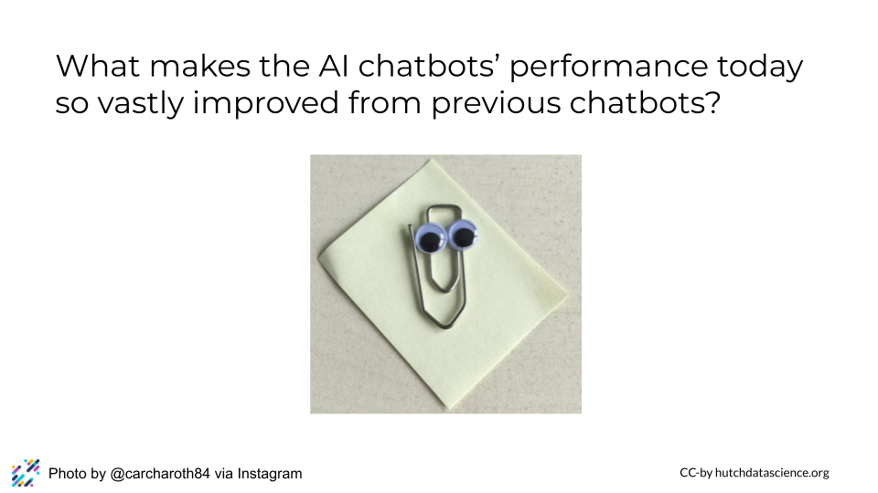

A good AI model is accurate – you need it to give answers that are correct or at least useful. They are also computationally efficient because we need them to give the answer back in a reasonable amount of time. We also don’t want to spend tons of money on the computation it takes for the chatbot to work.

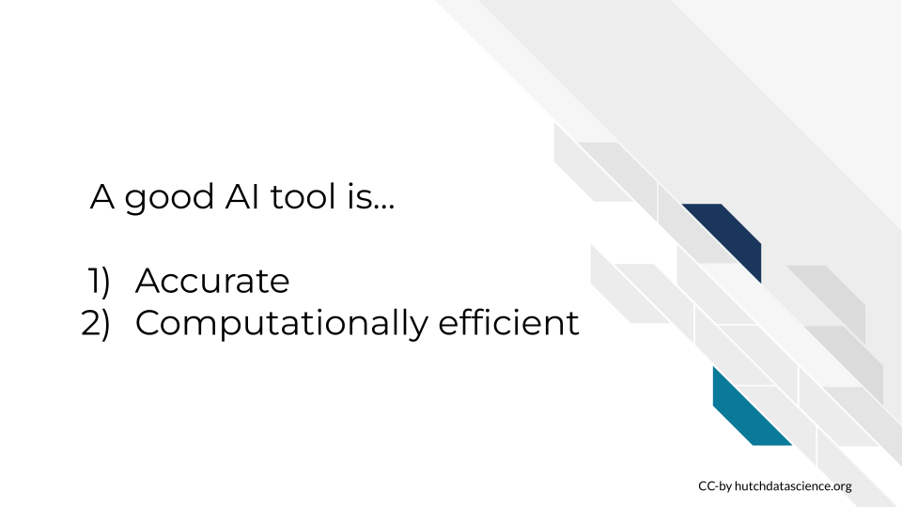

## 24.3 What makes an AI model accurate?

Let’s talk about the basics of what makes an AI model accurate. In order to understand this, we need to discuss some principles behind Machine learning.



Picture you were teaching someone (like an AI model) to identify apples from bananas. The training data you might give them would be a series of apples and bananas and you would label which were bananas versus apples.

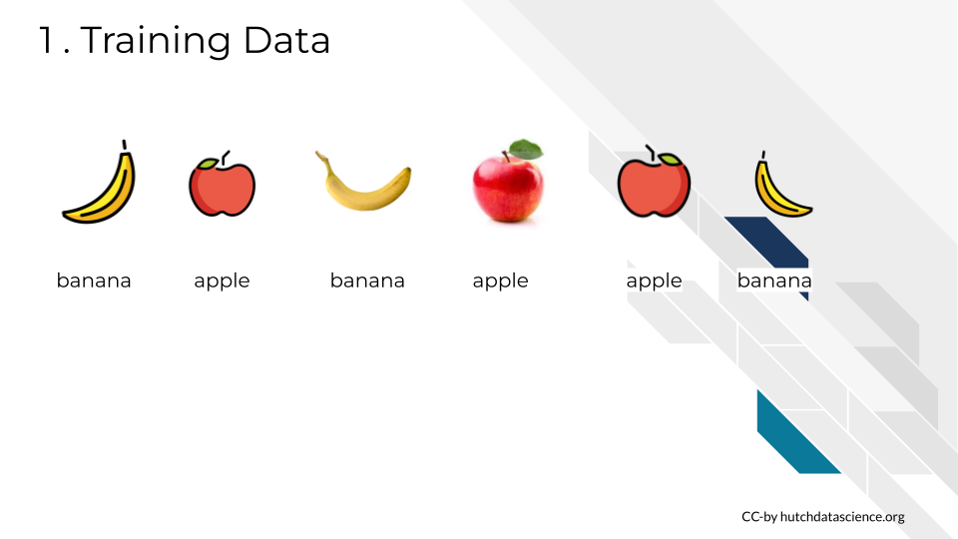

You could then test the model’s abilities ability to identify apples and bananas based on this training by giving them a fruit to identity. Assuming the fruit you gave them is reasonably identifiable from their training, they should accurately identify an apple.

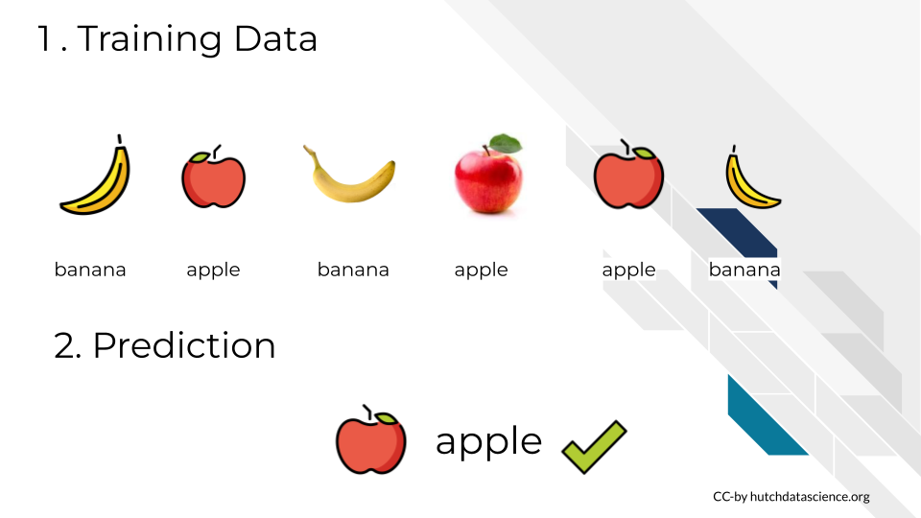

However, if the test you give the model is outside the kind of data they were trained on, they might not do well with it. For example if you didn’t provide any green apples and then you test the model with a green apple. It may or may not succeed.

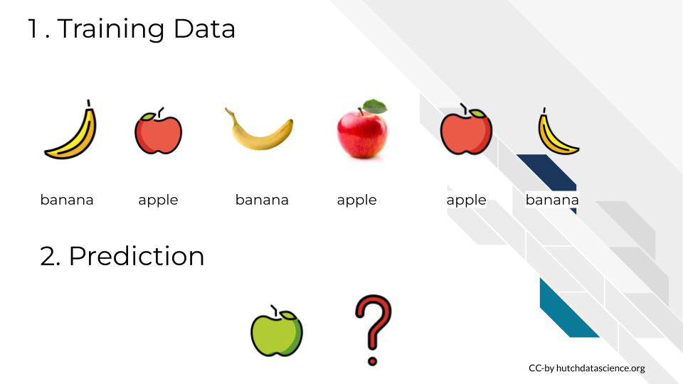

To address this gap in the model’s knowledge, you might add supplementary training data and retrain it so that it understands that apples could also be green.

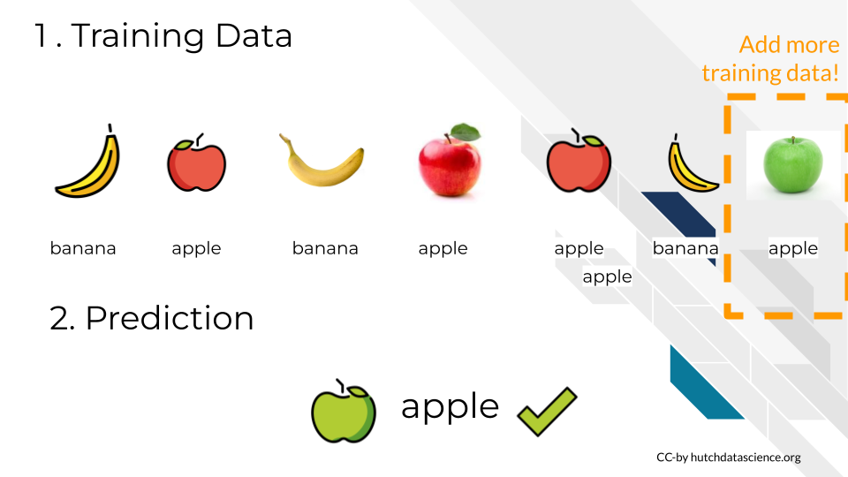

However, this added training data may help for the identification of green apples, but if given something similar to an apple but not – say a pear. It may incorrectly identify a pear as an apple if it hasn’t ALSO been trained on pears.

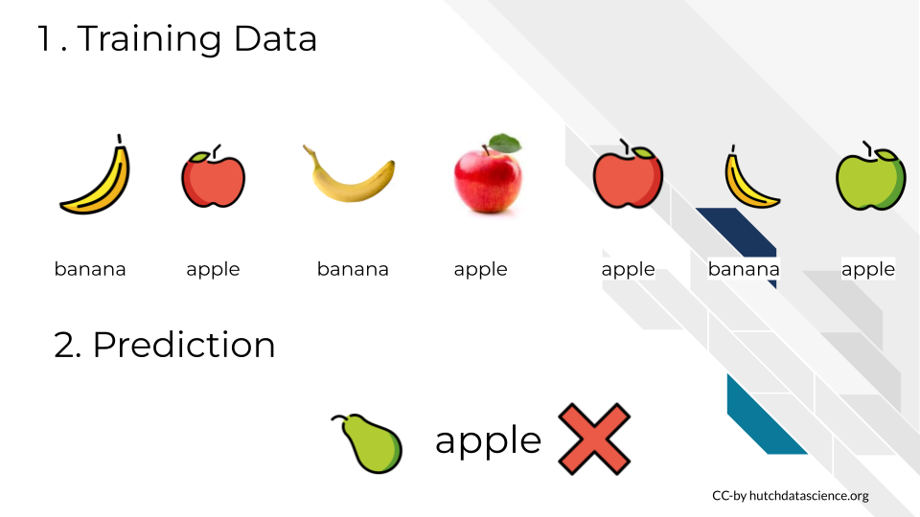

This may feel silly to you – why couldn’t it identify a pear – but this is because you are a really well trained AI. (Actually just the I, you presumably aren’t artificial). You’ve seen lots of fruit in your life – you’ve collected a lot of training data on this task and have no problem identifying a pear from an apple.

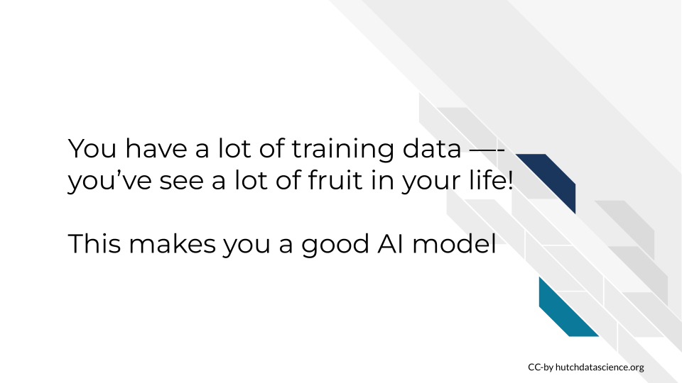

But we could throw you off too.



When you look at this image of a hybrid apple-banana, if AI models could feel, this is how they would feel.

## 24.4 What makes an AI model efficient?

Let’s talk about the basics of what makes an AI model accurate. In order to understand this, we need to discuss some principles behind Machine learning.

Let’s return to apples.

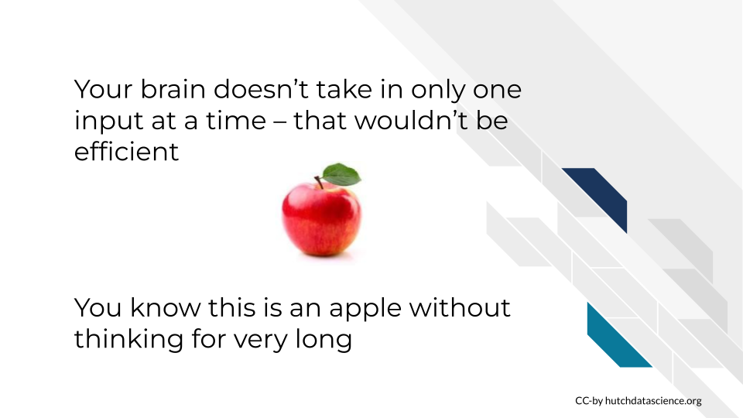

With the above image, you don’t need much time to look at that picture and know that that is an apple. You don’t have to think about this for very long.

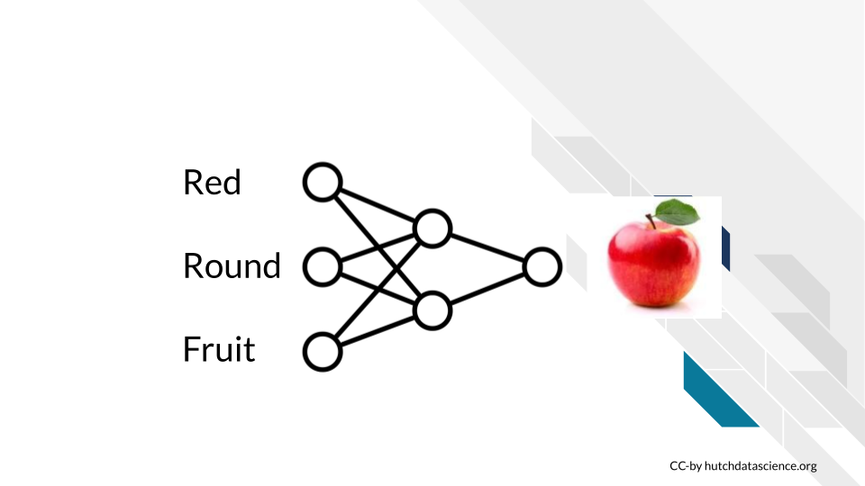

With the above image, you don’t need much time to look at that picture and know that that is an apple. You don’t have to think about this for very long. You didn’t take in one piece of information at a time.

This type of information processing is what neural networks are based on. Neural networks are when computers mimic how brains work to process information.

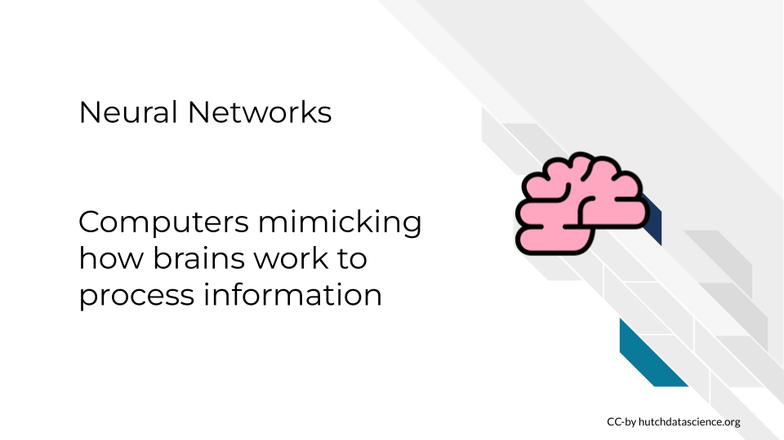

Think about how you’d read the following paragraph:

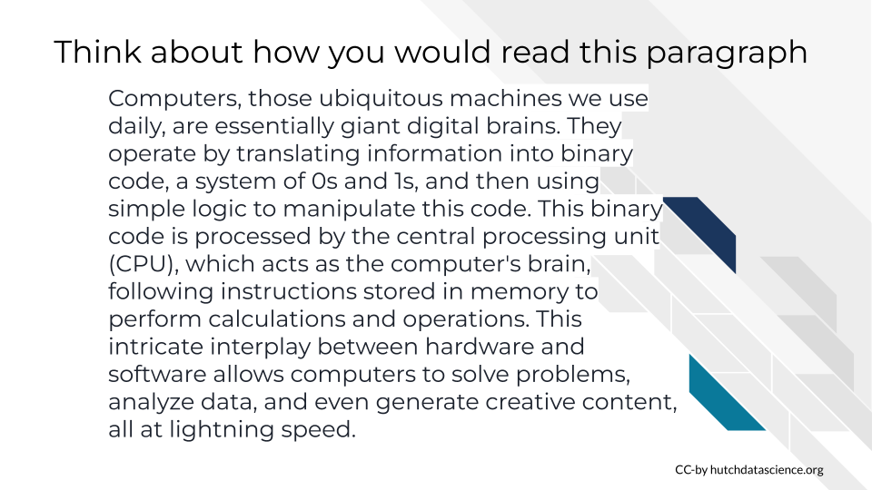

**Did you read each word, in order from start to end?**

OR

**Did you pick out keywords by skimming and getting the gist? Maybe later going back to pick up context you missed?**

The old way AI models worked is that they would read sequentially – from start to finish. And as you may sense, that is a slower way to read.

Alternatively, the new algorithms often use Attention mechanisms. These algorithms work analogous to skimming the input text.

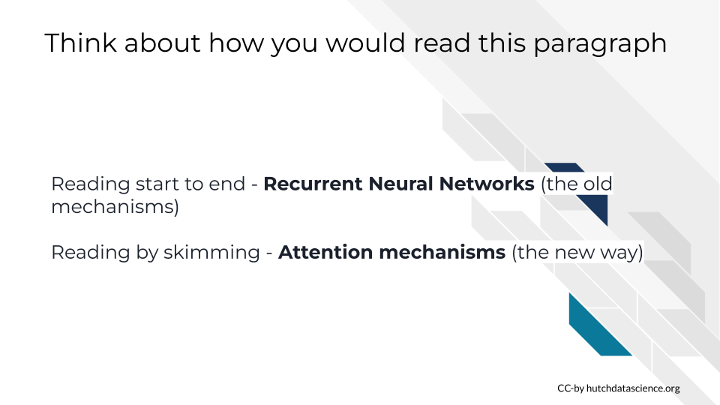

However, you could also probably sense that just because the new way of attention mechanisms are faster doesn’t mean that for all uses they are more accurate – by skimming you sometimes can miss important information.

Regardless of that, let’s walk through more about this analogy to get a sense of how attention mechanisms can work.

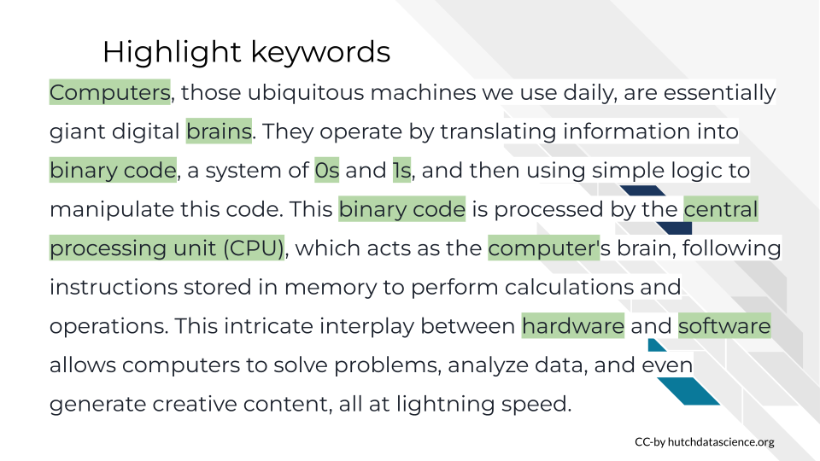

First we might highlight keywords in this paragraph. And meanwhile the words and phrases that are processed would be chunked into units called “tokens” the most important tokens we would focus on first with those attention mechanisms we referred to.

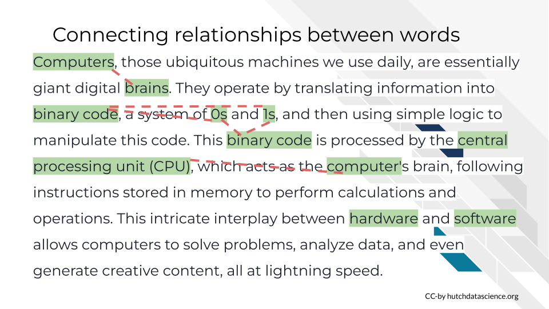

When we connect these relationship between these words we might already start pulling out some of the meaning of this paragraph. Grabbing these relational words will help us piece together more meaning.

Lastly we might pull out some contextual information from the other words we left behind.

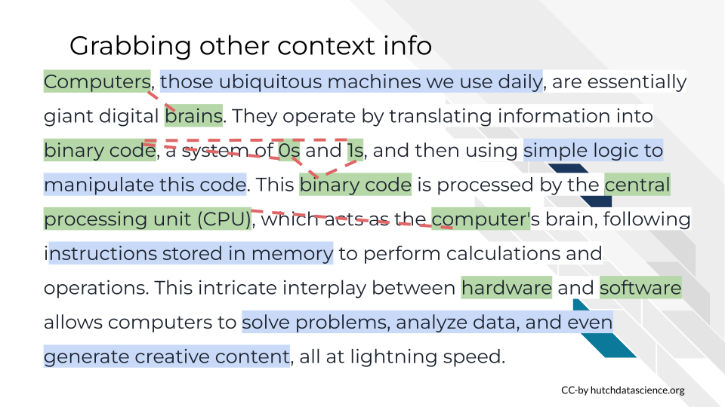

Let’s here it straight from an AI model. We asked bard to tell us what phrases it would pull out as keywords with attention mechanisms if we gave it this paragraph.



Without these recent advancements in attention mechanism algorithms, the large language models that we see today would not be possible. Its these computationally efficient mechanisms that have allowed large language models to be possible in addition to the physical hardware improvements in computing.

## 24.5 Putting it together

In summary, a good AI model is accurate – this is largely determine by its training data being high quality, relevant and properly processed.

A good AI model is also computationally efficient. We need to use algorithms that can efficiently and properly process data.



In order to visualize this, we’ve made a fake machine learning machine to describe AI. AI models can take a lot of different forms and functions and this visual is merely a tool to understand generalities about components of AI. It is not meant to be a detailed representation of any given AI model.

But we can discuss AI tools in terms of their:

* *input* what is the user of the tool providing?
* *processing (including algorithms)* – what are we going to do with that input?
* *training data* - how was the mode trained? what information was it trained on?
* *output* - what are we returning to the user of this AI tool?

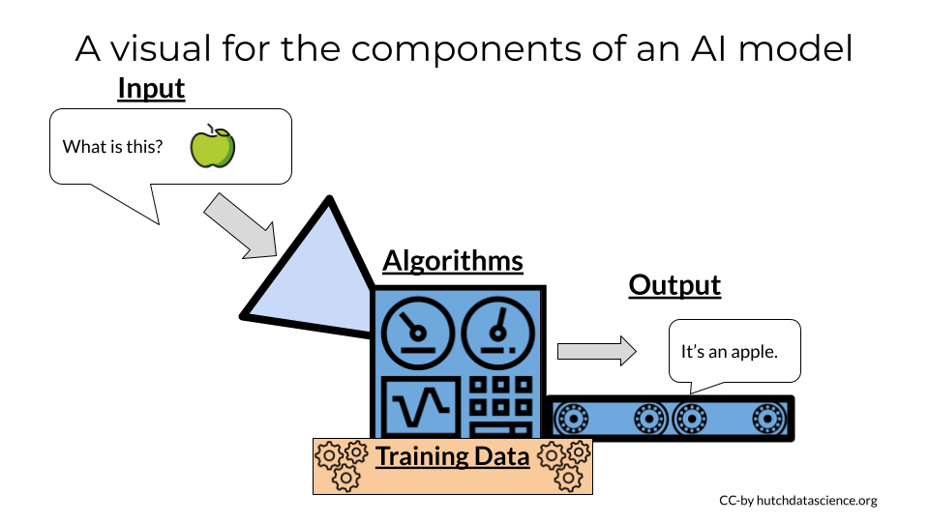

Each of these components can get very complicated very quickly. Although we won’t go through the details of these in this course, we will discuss practical aspects of these in terms of customization for AI needs.

Large language models are one popular type of AI tool. So we can talk about the components of these models in the context of this visual.



Large language models are one popular type of AI tool. So we can talk about the components of these models in the context of this visual. Tokens are units of a language (these might be words or phrases). Transformers are what organize tokens to find the meaning/context. Meanwhile to do this processing tokens are coded as Embeddings these are numerical representations of tokens. Encoders are what processes input text from a user. Meanwhile Decoders generate output text that is sent back to the user.

In summary:

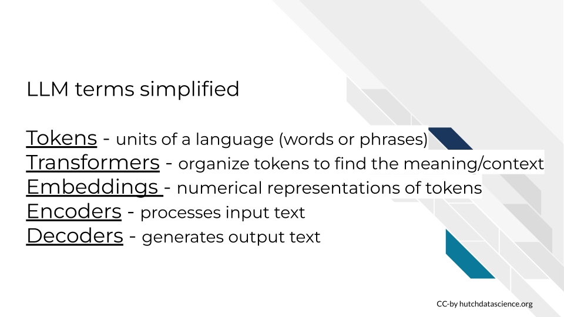

One more important point about AI models. Their training and training data is critical. You have likely seen and heard about many biased things that large language models have said. This is because the language they were trained on – the language of human beings in our society – was also very biased.



To summarize, for AI models can only be as good as their training. So garbage training data in means biased garbage as output.

# 25 Determining your AI needs

## 25.1 Learning objectives:

* Establish your AI project goals
* Detail how these goals are not currently accomplished by a currently existing AI tool
* Identify what kinds of customizations your AI project requires.
* Evaluate the resources and staffing needs you will have for this project.

## 25.2 Intro

A project that is ill defined is doomed to fail or worse be a chronic headache and source of stress before it fails.

In this chapter we will describe the questions and considerations you should contemplate while planning for an AI project. The first of such considerations is basic: What are your goals and uses cases and how are these use cases something that is not currently achievable by currently existing other products?

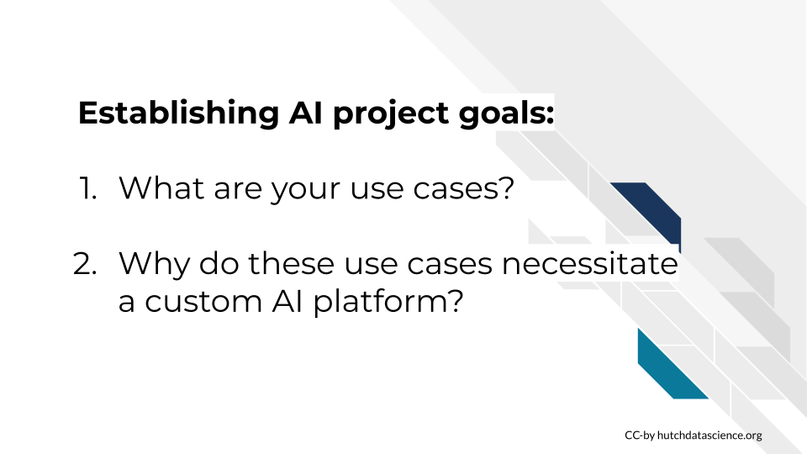

Please take a moment now to jot down answers to the above questions for your project’s goals.

Let’s return to our oversimplified machine learning machine to discuss our possible case categories.



Recall that we’ve described AI tools as having the following:

* *input* what is the user of the tool providing?
* *processing (including algorithms)* – what are we going to do with that input?
* *training data* - how was the mode trained? what information was it trained on?
* *output* - what are we returning to the user of this AI tool?

Please take a moment now to jot down the answers of what these items are for your impending AI tool project.

## 25.3 Generalized Custom AI Use Cases

Here we will discuss three bins of AI tool customization needs that we will discuss for the rest of the course. Keep in mind that these customization categories are for the purposes of discussion and not necessarily google-able terms.

Note that these categories of AI customization needs almost never mutually exclusive. It is possible (and probable) that your project may have multiple or all of these needs. The more needs you have the more complicated your project will likely be. So carefully consider what is truly needed for your project.

However, these are increasingly doable needs to address. There are a growing number of [helpful communities](https://huggingface.co/) and developers who are experts in customizing interfaces, security, parameters, algorithms, data handling and more for AI tools.

### 25.3.1 Customized Knowledge

Perhaps the most common AI need is customized knowledge. This means that existing AI tools are not properly trained for the use case. Perhaps the input is domain specific and the training data or training methods have not adequately prepared existing models to provide useful output.



Perhaps the output of existing AI models is incorrect, not useful or even harmful. This means some better training is needed in order to meet your AI needs.

## 25.4 Customized Security

Many field have data that could benefit from AI tools but may be dealing with data that is private and needs protection. It is highly dangerous and probably illegal in many cases to share protected data with commercial AI platforms. So customized security solutions for AI tools is not an uncommon use case.



This doesn’t mean protected data can’t be used with AI tools, but it does mean the AI solutions involved with projects with protected data need to be very carefully planned and constructed. And respective experts should be consulted about these solutions to make sure patients or customer’s data is being kept safe!

## 25.5 Customized Interface

Perhaps your project could benefit from the power of AI but you need to do this automatically or you need your users to access AI tools from a customized interface.



This *may* be the most straightforward of the AI needs. An increasing number of AI tools have APIs available that can be used underneath the hood of your AI project.

The upcoming chapters will discuss each of these customized AI needs and examples of existing options in more details.

### 25.5.1 Generalized strategies for these needs

Take a moment to categories which of these AI needs are the largest priorities for your AI project. Note that the more customized needs you have the more work you will have that will be required by your team. And if you don’t have a large amount of technical expertise on your team, this will be required if you have a lot of custom AI needs.

Lastly, if none of the above describe your customized needs; you may want to consider whether you truly need a custom solution! It could be that commercially available AI platforms will fit your needs OR you may NOT need AI as a part of your project at all!

Don’t let the glitter of AI commit you and your team to a project that is ill defined!



Carefully consider what the project truly needs. Which of these needs are non negotiable versus “nice to have”? Note that if you are working with protected data, protecting this data is never negotiable, but other customized needs may be.

Below is a very general breakdown of what types of solutions will likely be a part of your AI project based on what needs you’ve identified.



For each type of need there is often a continuum of solutions that require less to more investment that we will discuss examples of in the upcoming chapters.

* For **customized knowledge** needs, you will likely be needing to train a model for your domain specific knowledge.
* For **customized security** needs, you may need to deploy an AI tool on a secure server or use some other type of security layering tool
* For **customized interface** needs, you may need to use an API of an existing AI tool or use prepackaged AI tools that you can embed in your website/app.
* For **customized handling** needs, you will likely need to build and deploy a custom AI model.

## 25.6 The Whole Picture

As with most management decisions, it’s never as simple as deciding what the project needs, its also necessary to evaluate what expertise, resources, and time you have available to you and your team.



**You need to evaluate:**  
1. the technical expertise you have available to you 2. Your funding situation. 3. The quickness of the deadlines to which this AI tool needs to be operational.

### 25.6.1 Technical expertise needs

What technical expertise you have available on your team? If you do not have the expertise needed for your strategy, will you be able to use funds to hire someone who does? Can you involve a collaborator who has a team with complementary technical expertise to what your team provides? You also need to consider possible staff turnover if you are in an academic institution or other system where this is expected. Staff turnovers will make software development projects take longer even if the knowledge transfer between staff is optimized.



The more customization needs your project will need, the more you will need more technical expertise support on your team. Lone developer situations are not ideal; team work is better for development.

In this table we describe what kinds of technical expertise you will likely need on your team based on what kinds of customization AI needs your project entails. Keep in mind you can likely minimize these staffing needs if you pay for products that are prepackaged. Prepackaged products (which we will discuss in future chapters) generally require less expertise but will not allow you the same freedom for more granular customization.



* For knowledge needs, you will likely require a team who is comfortable with data handling techniques. It will also be ideal if they have a certain knowledge of machine learning algorithms.
* For security needs, it’s likely you will need someone comfortable with back end development and secure computing. Depending on your strategies with this need, it would also be good if you have a front end developer’s help.
* For interface needs, you’ll likely need a front end developer, as well as someone who is comfortable with using APIs, which also means potentially a back end developer.
* For Handling needs, you will require nearly all of these skillsets in order to deploy. So you may want to carefully consider whether this is necessary for your project if your team does not already have these skillsets.

### 25.6.2 Funding needs

Funding needs for AI projects is not necessarily straightforward. there are a number of costs you will need to consider.

Two major categories of costs include **computing** and **staffing**

 #### Computing costs

AI projects can be costly. And this is true whether you use a “prepackaged” AI solution or build one from scratch.

It is a good idea to estimate your computing costs before you begin your project.

* How big are the data the users would be inputting?
* How much would your AI tool cost per query (on average)?
* How many queries might a users submit?
* Given the answers to the above, how many users would you be able to accommodate for a given for a given day/month/year? – expect the best/worst case scenario of your tool being massively popular!
* Will users being paying for this service? Will the rate at which they pay cover your computing and staffing costs?



Whether you build “from scratch” or borrow commercial AI tools, you will likely not be able to avoid computing costs. Keep in mind that for certain levels of usage [it may not actually be more cost effective to run your own computing infrastructure.](https://lajavaness.medium.com/llm-large-language-model-cost-analysis-d5022bb43e9e)



In this computing cost analysis graph from La Javaness R&D, they demonstrated how after a certain level of usage it is actually more cost effective to outsource infrastructure to ChatGPT’s API instead of building their own model and hosting it themselves.

#### 25.6.2.1 Staffing costs

Custom deployments will require more technical expertise on hand as we discussed in the previous section – think salary costs. You will need to estimate whether it is more cost efficient for you to have in house developers work on this or use borrow commercial computing infrastructure.

It’s not just about developers. Ideally you would also have:

* A user experience designer to help you make sure the AI tool you build is actually useable by human beings!
* A project manager that will help everyone save time and meet deadlines
* Administration to actually help you hire the individuals you need, negotiate data use agreements, and all the other behinds the scenes paperwork necessary to keep the ship sailing smoothly.

### 25.6.3 Time needs

Time is a resource. For the purposes of your AI tool project goals, you should assess how much time you have. When determining how you will meet your AI strategy needs is how quickly you need these AI needs to be met.



* How quickly does this need to be ready? And what is determining that deadline? Can these deadlines be pushed?
* How long does this AI tool need to be maintained?

Note that more customized deployments will require more development time as compared to “prepackaged” AI tools. If you rush development [technical debt](https://www.productplan.com/glossary/technical-debt/) *will* be incurred. Technical debt will need to be paid at some point for this project to be sustainable.

## 25.7 Example project strategies

Up until this point we’ve been discuss strategies in very vague terms. To bring this discussion to specifics, we will discuss some example AI tool project strategies you may employ based on what combination of customization AI needs you have.

These example project strategies are in the order of least to most resource and time investment.

In the left most column is described what kinds of customizations are able to be made given the described strategy.



* In the example column we have links to resources and platforms that would be a central point or product for this strategy.
* The technical expertise column describes vaguely how much technical expertise in house you would need to deploy the example strategy.
* The funding column describes approximately the funding costs that would be associated with the strategy (but not this is highly variable given specifics of a project).
* The time column describes how long it would take to deploy this solution.

### 25.7.1 Cogniflow example

[Cogniflow](https://www.cogniflow.ai/ai-playground) is example of an AI tool that meets customized interface needs. It is a service that does not require code but has prepackaged AI tool solutions like chatbots and receipt digesters that can be readily deployed to a website. It is a subscription service but does not take much time to set up or maintain. This would not allow for much customization but it is a ready to go solution that would not necessitate hiring more staff.

### 25.7.2 PrivateAI

[PrivateAI](https://www.private-ai.com/pricing/#privategpt) is an example of an AI tool that meets customized security needs but not really other customizations. This services has security layers that allows you to use other commercial AI platforms with PII and PHI. It is HIPAA compliant and is a pay-by-use service. It also would not take much time to use and would not require additional time to use. Of course, due to the importance of keeping protected data protected, it should be confirmed that PrivateAI is an acceptable use based on any legal agreements.

### 25.7.3 ChatGPT API

[ChatGPT’s API services](https://openai.com/product) are an example of an AI tool that meets a customized interface and knowledge needs. Using an API would allow you to use the power of chatGPT but from underneath the hood of a custom made app or website. Additionally chatGPT’s API does allow for training models which means you could make it domain specific. Using an API would require more technical expertise than the previous two example strategies, but would not require building from scratch. This strategy can be a very customizable but not entirely from the ground strategy. It does of course, involve paying chatGPT for computing costs, so that as well as the staffing needs should be considered when employing this strategy.

### 25.7.4 Hugging Face

[Hugging Face](https://huggingface.co/)is a community and repository of open source AI and machine learning models of all kinds of varieties. The resources available on Hugging Face would allow you to customize an AI tool to meet all the needs you might have. The open source nature of the AI models, datasets, and examples available on Hugging Face means that this not completely from scratch either but would require more technical expertise to utilize the resources here. The tutorials and resources on hugging face would allow you to control and build a AI model that fits every need you might have. But remember computing and staffing are always costs, hence why we have not said that this is *necessarily* a less expensive strategy. Depending on the size and technical expertise of your team it will likely take more time than the other strategies.

## 25.8 Conclusion

In the upcoming chapters we will discuss the ins and outs of customized AI needs and propose other strategies and considerations you will need to grapple with.

# 26 Customized Knowledge for AI

## 26.1 Learning objectives:

* Understand the motivation behind customized knowledge needs for AI tools
* Discuss a variety of low to high investment strategies for meeting customized knowledge needs
* Define and be able to contrast the differences between prompt engineering, promoting tuning, fine tuning, and training a model from scratch.

## 26.2 Intro

Customized knowledge needs are perhaps the most common AI tool need. And intuitively many can understand this. Just as you wouldn’t ask your primary physician to fix your motorbike, neither should you depend on an AI model for something it isn’t trained for.



When we are discussing customized knowledge needs, we are describing that existing AI models are not accurately addressing the needs we have. The output from the AI models is incorrect or not useful.



## 26.3 Summary of possible strategies

If the goal of customized knowledge is to get better output from an AI model, there are multiple strategies we can employ to achieve this goal. We will discuss them in order to lowest to highest investment. It’s generally best to see if the low investment strategies can meet your needs before turning to the higher investment strategies.



In summary, we will cover 4 different strategies for obtaining better output from an AI model.

* **prompt engineering** is when the user asks a better question as opposed to retraining the model.
* **prompt tuning** is when we use an iterative prompt and feedback strategy to make the model work better. It is lower investment attempt than fine tuning.
* **fine tuning** is when we give additional training to the model to have it perform better. So in our opening example, fine tuning is like sending the primary care fellowship to learn an additional skill set.
* **training from scratch** is when we quite literally build a whole new model from the beginning. For most use cases this is not necessary and it is prohibitively expensive.

### 26.3.1 Prompt engineering

Sometimes its not the model who needs training, its the user. AI models, just like humans, are not mind readers, and just as we all learned how to google, we also need to learn how to engineer prompts.



[Best practices for prompt engineering according to Google](https://cloud.google.com/blog/products/application-development/five-best-practices-for-prompt-engineering)

1. Know the model’s strengths and weaknesses
2. Be as specific as possible
3. Utilize contextual prompts
4. Provide AI models with examples
5. Experiment with prompts and personas
6. Try chain-of-thought prompting

In addition to prompt engineering it’s also vital to note that different AI models are trained on different things. So if one is not giving you the output you need, try another!

For LLMs, you can use <https://poe.com/> or <https://gpt.h2o.ai/> to test out prompts on multiple AI platforms side by side.



### 26.3.2 Prompt tuning or “P-tuning”

Because prompt tuning sounds a lot like prompt engineering it would be easy to think these strategies are the same, but they are not.

Prompt tuning is a lower stakes type of tuning where you use your prompts to help train an LLM. It’s more efficient than fine tuning. But it may or may not address your customization needs.

Basically you can think of prompt tuning like giving the LLM more context and instructions around what you are trying to receive back from it. [A good analogy from this IBM article](https://research.ibm.com/blog/what-is-ai-prompt-tuning) is that prompt tuning is like crossword puzzle clues for the LLM. It guides the model toward the right answer.



You can test out prompt tuning without doing software engineering by trying out the [gpt.h2o platform](https://gpt.h2o.ai/)



### 26.3.3 Fine Tuning

First some context around fine tuning.

Let’s make a hiring analog. If you needed someone to fulfill a specialized education job, you wouldn’t train a baby who has almost no knowledge as a starting point. This would be unnecessarily time costly and inefficient. Instead, you find a person who has a lot of the training you need and then fine-tune their skills.



That is the strategy of fine tuning. We aren’t going to create a model from scratch, instead we’re going to find one that has the training that *most closely* overlaps with our needs but we will provide them with additional training for our specific needs.

But fine tuning also might cost money, so before we jump to this strategy we need to check one more time whether we’ve surveyed the available models for their fitness of our project’s needs. Are you sure no other model works? if you’ve only tried ChatGPT go try other AI platforms. If an LLM is what you are looking for you can [read our paper for a summary](https://www.nature.com/articles/d41586-023-03023-4).



### 26.3.4 Find a base model to start with

For us to fine tune a model, we’ll first need to identify the base model that gets closest to what we are looking for.

When looking for a base model we want to consider at least these items congruently:

1. Which is trained on data most similar to your application?
2. Which models have performed the best based on your prior testing?
3. No need to unnecessarily increase our computing costs, try to find the smallest one that performs the best. [Note that bigger doesn’t mean it performs better](https://huggingface.co/blog/large-language-models) – think jack of all trades master of none. You want a model that isn’t too general.



Speaking of the size of models, here is a visual demonstrating the sizes of a lot of the LLM’s in existence as of March 2023



It also might be worth considering how these models are related. Perhaps an earlier, smaller version would be easier for you to train than using the latest, biggest large language model that doesn’t contain better information for your purposes.



Here’s places you can learn about AI models that are out there:

* [This repository has a nice summary of a lot of currently available open source LLMs.](https://github.com/eugeneyan/open-llms)
* [Practical Guide to LLMs](https://github.com/Mooler0410/LLMsPracticalGuide)
* [HuggingFace has all of the AI models - multimodal and more that we could want](https://huggingface.co/models)

Lastly, you should consider how you will evaluate the AI model’s performance? Where did the existing models you tried fall short?



* What information do you think would help close the knowledge gap of the existing models to meet your needs?
* Do you have the data you might be able to fine tune a model to help it perform better?
* How much cleaning will this data need?
* Is this data unprotected and freely able to be shared or submitted to an open source repository?

We’ll discuss strategies for evaluation and data privacy in the upcoming chapters. But now is a good time to keep this in mind.

## 26.4 Example strategies for Fine tuning

Just because you may have identified you require fine tuning for an AI project doesn’t necessarily mean you will need a lot of technical expertise. There are some solutions like [MonsterAPI](https://monsterapi.ai/) and [H2o](https://gpt.h2o.ai/) that allow for fine tuning without code. These might be good platforms to explore either as a way to meet needs or to experiment to determine a larger strategy.



As described in the previous chapter, [Hugging Face](https://huggingface.co) also has many tutorials on how to fine tune. This strategy would involve more code, frameworks, and software development.

If you do decide to build using open source models from Hugging Face or elsewhere you should consider these stages for your project timelines:



In this course we have already discuss defining the use case and selecting an existing model and adapting that model. But in the upcoming chapters we will discuss deployment and evaluation of models.

# 27 Customized Security for AI

## 27.1 Learning objectives:

* Understand the motivation behind customized security needs for AI tools
* Discuss a variety of low to high investment strategies for meeting customized security needs
* Define and be able to contrast the differences between secure AI services, deidentifying data, and deploying existing models on secure computing resources.

## 27.2 Intro

Customized security needs are perhaps one of the largest barriers keeping individuals in certain fields from using AI tools to their full potential. There are many legitimate reasons commercial AI tools cannot and should not be used with protected data.



Commercial AI products do not have data use agreements. They do not have to tell you what they do with your data. And if you work with protected data types that generally means you can’t use them.



Not all data types are safe to share for a variety of reasons. To protect patients or customers, Personal Identifiable Information (PII) Protected Health Information (PHI) cannot be used with online AI services or shared with others. Controlled Unclassified Information is another type of protected data that may be related to national security matters.

But protected data projects could highly benefit from AI!



* AI analysis tools as helpful diagnostic aids for use with health data, imaging data, genomic data.
* AI chatbots as an aid for financial or health guidance for patients or customers.
* AI to help detect when protected data has been leaked.

Protected data might be useful as training data for a problem and/or patients or customers may want to input data into a secure AI tool.



* Protected data needs should always be taken seriously! Before employing any AI solutions that involve protected data consult your legal experts and IRB!

## 27.3 Data security basics

Before we dive into AI related solutions, it’s a good idea that we remind ourselves of some of the best practices for data privacy



* Fewest individuals have access to the data as possible
* Least privileges as needed to complete a task. This is known as the “principles of least privilege”.
* Individuals who do have access should have to provide authentication to make sure only authorized individuals can see the data.
* Data use agreements need to be used when individuals need to be added to the authorized list

## 27.4 Secure AI solutions for protected data

Solutions exist for AI tools for protected data – some require more careful planning thought and expertise. Here we have ordered these example strategies in order of least to most investment.

 Whenever possible consult data security and legal experts to be sure that you are not exposing patients or customers’ data and risking their privacy or finances.

* Use AI services that keep data private – some AI tools have specialized tools that allow you to keep data private. Be sure to carefully read their terms of use to gain an understanding of how they keep the data secure. Consult security
* Obscure protected data type by hand and use AI models. In some cases this is not possible to do and still have meaningful data. And, care must be taken to make sure that data it thoroughly and properly secured.
* Deploy existing model on secure servers. This takes the most technical expertise to carry out.

## 27.5 Data obscuring techniques

Whether you have an AI service perform this or you do it yourself (or both) there are multiple strategies for obscuring data. It is often not a bad idea to employ multiple safety nets to keep data safe.

In summary, here’s just a few of the techniques that can help make data sharing HIPAA compliant.



* Data Aggregation - summarize values to a higher level of grouping
* Data Masking - Replace data with symbols
* Data Anonymization - Replace data with randomized, fake data.
* Data Redaction - Remove the sensitive data

To further understand what this looks like, here’s an example of how these techniques might look with a toy dataset



In this toy example will illustrate roughly how a given technique may obscure the original data in the top row. This can give you a sense that some types of data are better for certain types of obscuring methods than others. But this also depends on what your goals for your AI project are.

Keep in mind that data anonymization may be more difficult with smaller datasets because of a concept called K anonymity. This principles means that you need to make sure that k number of individuals share the same attributes so that it is nearly impossible to identify any specific subject.

The strategy you choose should definitely include these two questions:



1. What protected items are included in your data
2. Your goals with said data with AI – what is the minimum amount of information you could include in the AI model or input in order to achieve the desired goals?

## 27.6 Example Security Customization strategies

In the table below we show three examples illustrating example strategies for using AI tools with protected data. These examples are in the order of least to most amount of technical expertise needed to implement.



### 27.6.1 PrivateAI

[PrivateAI](https://docs.private-ai.com/webdemo/) is a platform that allows you to use various AI models with private data. It works by detecting and redacting information that is likely protected like PII and PHI. It also has containerization options that allow you to run AI but not on their or other’s servers. It requires the least technical expertise to implement, but care must be taken to make sure that it will properly deal with your project’s particular type of protected data.

### 27.6.2 deidentify

[deidentify](https://pypi.org/project/deidentify/) is a Python package that can assist with deidentifying medical records using natural language programming. This is illustrative of one way you might attempt to deidentify data before using it with AI tools. Care must be taken to make sure that the deidentification process is thorough. You may also want to couple this with other tools that can detect PII or PHI data before you submit to an AI tool. As always you will want to make sure that it properly handles your project’s data and that before you submit the data you’ve deidentified you have other reputable sources double or triple check that no protected information is being leaked.

### 27.6.3 AWS servers + HuggingFace

[Amazon web services](https://aws.amazon.com/compliance/hipaa-compliance/) (and its competitors) generally offer HIPAA compliant computing solutions. Whether you use this service, an institutional cluster, or some other server is a decision you will have to make on a case by case basis. But regardless, this is the most technically involved solution. This is most likely the strategy you’d need to employ if security is not your *only* customization you need. In this instance you would borrow a model and set up from [HuggingFace](https://huggingface.co/models) and build your AI tool more or less from scratch (but don’t build the model from scratch)

## 27.7 Always double, triple, quadruple, check

As opposed to other types of AI customizations, the strategies we’ve discussed in this chapter are the most imperative that you get cleared through the proper channels before deploying (if you do this incorrectly it may be illegal). It is a matter of privacy and safety for patients/customers that you get this right. So it makes sent to check with your in-house experts like institutional review boards and data security experts!



# 28 Customized Interfaces for AI

## 28.1 Learning objectives:

* Understand the motivation behind customized interfaces needs for AI tools
* Discuss a variety of low to high investment strategies for meeting customized interface needs
* Define and be able to contrast the differences graphics user interfaces and command line interfaces.

## 28.2 Intro

Sometimes you need the power of AI underneath the hood of your own website/app. There are multiple strategies you can employ to achieve this.



In this scenario, you need to have your website or app that has its own interface. Interfaces are how people will use your app. There’s two main interface types that are most common: GUIs and Command line

 - GUI - stands for “Graphics user interface” – it’s the most widely used. Here users point and click buttons to tell a computer and its software what they’d like to do. - Command line - generally for software that is for individuals with more technical expertise and comfort with programming. In this interface, users type commands in order to perform tasks

In this scenario we could maintain all of the same machinery but merely have a different platform where our users arrive.



## 28.3 General strategies for custom interfaces

There are multiple strategies for empowering your website or app with an AI model or tool. These are arranged in order from lowest to highest investment.



* Embed premade AI tools in your app - There are prepackaged solutions for standard AI tools that you might want for your website. These are subscription services but require minimal expertise to employ.
* Use an API (Application programming interface) underneath the hood of your app – an increasing number of LLMs and other AI tools have APIs available. APIs allow one to access a website or tool programmatically. This means that you can build your tool in such a way that underneath the hood it is powered by an AI tool.
* Deploy existing model in your own app - this is the most technically intensive solution but would be necessary if you require other types of customizations for your AI tool.

Usability experts are going to be really helpful for carrying out this kind of need. Interface designs can make or break a tool’s usability and hence popularity!



## 28.4 Examples of AI customized interface strategies

## 28.5 Premade AI tools

Some services like [Cogniflow](https://www.cogniflow.ai/ai-playground) offer prepackaged AI services like chatbots that you can embed in your website or tool. This has the advantage of being minimal maintenance or software development knowledge needed. But as always, you generally don’t have the ability to highly customize or finely tune these types of options. They generally are subscription services or pay for what you use.



## 28.6 AI tool APIs

Pre-package tools may only have certain options…



In contrast, APIs can be very powerful and allow you to incorporate all the power of an AI tool into your website/app. They also free you team from having to do as much back end development. Although not all AI tools have API access, an increasing number of them are developing this as an option.



Currently [ChatGPT’s API](https://openai.com/pricing) is the most well developed for LLM (it appears at the time of writing this) but of course it requires a higher cost subscription plan. [Bard may have a beta version of their API](https://medium.com/@novita_ai/how-to-use-google-bard-api-57a14d95bfa3) being further developed and released. Other types of AI models (not LLMs) often have API access as well like [Google Cloud’s speech to text API](https://cloud.google.com/speech-to-text).

## 28.7 Custom builds



If you need more than a custom interface but also custom knowledge, security you, or handling you will likely need to build custom AI solutions – again this requires more staff expertise

In the next chapter we will discuss custom AI builds.

# 29 Evaluating your customized AI tool

## 29.1 Learning objectives:

* Understand the motivation behind evaluating your customized AI tool
* Define your own goals for evaluating the accuracy, computational efficiency, and usability of your AI tool
* Recognize metrics that could be used for evaluation of accuracy, computational efficiency, and usability.

## 29.2 Intro

Evaluating a software tool is critical. This is for multiple reasons that feed into each other.



1. Evaluating your AI tool will help identify areas for improvement
2. Evaluating your AI tool will demonstrate value to funders so you can actually make those improvements

It’s important to keep the pulse on your project as it is developing. But once you have a stable AI tool, its a good time to gather initial evaluations.



As a reminder, generally a good AI tool is accurate in that it gives output that is useful. It is also computationally efficient in that we won’t be able to actually deploy the tool if it is computationally costly or takes too long to run a query.



But for the purposes of evaluation, we’re going to add one more point of evaluation which is a good AI tool is usable. Even if you do not have “users” in the traditional sense; you are designing your tool only for within your team or organization, you will still need it to be functionally usable by the individuals you have intended to use it. Otherwise the fact that it is accurate and computationally efficient will be irrelevant if no one can experience that accuracy and efficiency.

## 29.3 Evaluating Accuracy of an AI model

How you evaluate the accuracy of your AI model will be highly dependent on what kind of AI model you have – text to speech, text to image, large language model chatbot, a classifier, etc. This will determine what kinds of “ground truth” you have available. For a speech to text model for example, what was the speaker actually saying? What percentage of the words did the AI tool translate correctly to text?

Secondly your evaluation strategies will dependent on what your goals are – how do you define success for your AI tool? What was your original goals for this AI tool? Are they meeting those goals?



LLM chatbots can be a bit tricky to evaluate accuracy – how do you know if the response it gave a user was what the user was looking for? But there’s a number of options and groups who are working on establishing methods and standards for LLM evaluation.

**Some examples at this time:**

* [MOdel kNowledge relIabiliTy scORe (MONITOR)](https://arxiv.org/pdf/2310.09820.pdf)
* [google/BIG-bench](https://github.com/google/BIG-bench)
* [GLUE Benchmark](https://gluebenchmark.com/)
* [Measuring Massive Multitask Language Understanding](https://github.com/hendrycks/test)



## 29.4 Evaluating Computational Efficiency of an AI model

Evaluating computational efficiency is important not only for the amount of time it takes to get useful output from your AI tool, but also will influence your computing bills each month. As mentioned previously, you’ll want to strike a balance between having an efficient but also accurate AI tool.

Besides being shocked by your computing bill each month, there’s more fore thinking ways you can keep tabs on your computational efficiency.



Examples of metrics you may consider collecting:

* Average time per job - How much time
* Capacity - Total jobs that can be run at once
* FLOPs (Floating Point Operations) - measure the computational cost or complexity of a model or calculation [More about FLOPs](https://www.kdnuggets.com/2023/06/calculate-computational-efficiency-deep-learning-models-flops-macs.html).

## 29.5 Evaluating Usability of an AI model

Usability and user experience (UX) experts are highly valuable to have on staff. But whether or not you have the funds for an expert is UX to be on staff, more informal user testing is more helpful than no testing at all!



Here’s a very quick overview of what a usability testing workflow might look like:

* Decide what features of your AI tool you’d like to get feedback on
* Recruit and compensate participants
* Write a script for usability testing - always need to emphasize that if they the participant doesn’t know how to do something it is not their fault, its something that needs to be fixed with the tool!
* Watch 3 - 5 people try to do the task – often 3 is enough to illuminate a lot of problems to be fixed!
* Observe and take notes on what was tricky
* Ask participants questions!

[We recommend reading this great article about user testing](https://uxstudioteam.com/ux-blog/usability-testing/) or reading more from this [Documentation and Usability course](https://jhudatascience.org/Documentation_and_Usability/index.html#available-course-formats).

There’s many ways to obtain user feedback, and surveys, and interface analytics.

 Some examples of metrics you may want to collect:

* Success rate - how many users were able to successfully complete the task?
* Task time - how long does it take them to do
* Net Promoter Score (NPS) - scale of 0 - 10 summarized stat to understand what percentage of users would actively recommend your tool to others.
* Qualitative data and surveys - don’t underestimate the power of asking people their thoughts!

Navigate the Evolving Legal Landscape of AI with Confidence

# 30 Introduction to AI Policy

In today’s rapidly evolving technological landscape, staying ahead of regulations can be challenging, especially when dealing with cutting-edge technologies like artificial intelligence (AI). This course equips decision-makers and leaders with the knowledge they need to navigate the legal complexities surrounding AI.

## 30.1 Motivation

By understanding the key legal considerations and emerging regulations, you can ensure your organization leverages the power of AI while staying compliant and mitigating potential risks. This course empowers you to make informed decisions and confidently utilize AI to achieve your organizational goals.

## 30.2 Target Audience

This course is targeted toward industry and non-profit leaders and decision makers.

## 30.3 Curriculum

In this course, we’ll learn about the state of existing AI laws, other laws and regulations that can apply to AI systems and products, how to create a strong AI policy for your organization, and how to develop compliance training for your workforce.

# 31 Building a team to guide your AI use

The legal and regulatory framework around AI systems is evolving rapidly. As someone in charge of making sure your organization is using AI wisely and properly, staying up-to-date on the laws and regulations is vital. It’s also something that is really difficult to do alone. Building a team of individuals that can help you confidently navigate the evolving legal landscape should be one of your top priorities as a leader.

There are multiple possible roles that you could fill, depending on what your organization’s AI needs and uses are. Having representation from technical, policy and social science backgrounds helps ensure a multidisciplinary, holistic approach to building and overseeing responsible AI.

1. *Legal council* that understands AI and the nuances of the rapidly changing laws can advise on regulations relevant to your organization.
2. *Policy and governance analysts* can research and draft internal policies on transparency, auditability, harm mitigation, and appropriate AI uses. They can also advise and assist with compliance.
3. *Data protection officers* who can aid with implementation privacy-by-design principles and handling personally identifiable information legally and securely are especially important for organizations that deal with personal data.
4. *Ethicists and oversight board members* are experts who can provide guidance on ethical issues and review systems for potential biases, risks, and policy compliance.
5. *Trainers and educators* can create and run programs aimed at keeping all employees aware of responsibilities in developing and using AI respectfully and in compliance with AI policies and regulations.
6. *Institutional Review Board members* are experts who review research studies (both before a study begins and while it is ongoing) involving human participants. Their job is to make sure researchers are protecting the welfare, rights, and privacy of human subjects. Institutional review boards are especially important for organizations involved in any human research that uses AI.

**This list is a starting point for you when deciding what sort of roles you need for your own team.** This is not an exhaustive list of all possible experts that you can gather. You should consult with your legal council, board members, and other oversight staff when building your team, so that you can address your own specialized needs.

# 32 VIDEO Building a team to guide your AI use

# 33 AI Acts, Orders, and Policies

With generative AI still new in many fields, from medicine to law, regulations are rapidly evolving. A landmark provisional deal on AI regulation was reached by the European Parliament and Council on December 8, 2023, with the [EU AI Act](https://artificialintelligenceact.eu/documents/)). These guidelines laid out in this document apply to AI regulation and use within the 27-member EU bloc, as well as to foreign companies that operate within the EU. It is likely the EU AI Act will guide regulations around the globe.

Countries outside of the EU are drafting their own laws, orders, and standards surrounding AI use, so you and your employees will need to do some research on what it and is not allowed in your local area. **Always consult your legal council about the AI regulations that apply to you.**

## 33.1 The EU AI Act

According to EU policymakers involved in writing the AI Act, the goal of the Act is to regulate AI in order to limit its capacity to cause harm. The political agreement covers the use of AI in biometric surveillance (such as facial recognition), as well as guidance on regulations for LLMs. The EU AI Act divides AI-based products into levels based on how much risk each product might pose to things like data privacy and protection. Higher-risk products with a greater capacity to cause harm face more stringent rules and regulations. Most current AI uses (like systems that make recommendations) will not fall into this higher-risk category.

Final details are still being worked out, but we do know several important aspects of this Act.

1. **All content generated by AI must be clearly identified.** Companies must also make it clear when customers are interacting with chatbots, emotion recognition systems, and models using biometric categorization.
2. Developers of foundational models like GPT as well as general purpose AI systems (GPAI) must **create technical documentation and detailed summaries about the training data** before they can be released on the market.
3. **High-risk AI systems** must undergo mandatory rights impact and mitigation assessments. Developers will also have to conduct model evaluations, assess and track possible cybersecurity risks, and report serious incidents and breaches to the European Commission. They will also have to use high-quality datasets and have better accompanying documentation.
4. **Open-source software** is excluded from regulations, with some exceptions for software that is considered a high-risk system or is a prohibited application.
5. AI software for manipulative strategies like deepfakes and automated disinformation campaigns, systems exploiting vulnerabilities, and indiscriminate scraping of facial images from the internet or security footage to create facial recognition databases are banned. Additional prohibited applications may be added later.
6. There are exceptions to the facial scraping ban that allow law enforcement and intelligence agencies to use AI applications for facial recognition purposes.

The AI Act also lays out financial penalties for companies that violate these regulations, which can be between 1.5% and 7% of a company’s global revenue. More severe violations result in greater financial penalties.

This is still a provisional agreement. It must be approved by both the European Parliament and European countries before becoming law. After approval, tech companies will have two years to implement the rules, though bans on AI uses start six months after the EU AI Act is ratified.

More information about the EU’s AI Act can be found in these sources.

[MIT Technology Review](https://www.technologyreview.com/2023/12/11/1084942/five-things-you-need-to-know-about-the-eus-new-ai-act/)

[Reuters](https://www.reuters.com/technology/stalled-eu-ai-act-talks-set-resume-2023-12-08/)

[EURACTIV.com](https://www.euractiv.com/section/artificial-intelligence/news/ai-act-eu-policymakers-nail-down-rules-on-ai-models-butt-heads-on-law-enforcement/)

[CIO Dive](https://www.ciodive.com/news/EU-AI-Act-penalties-guardrails-foundational-models/702192/)

## 33.2 Industry-specific policies

Some individual industries have already begun adopting policies about generative AI. They may also have long-standing policies in place about the use of other forms of AI, like machine learning. When in doubt, always check with the experts within your organization about what AI policies exist for your industry.

Some countries have also begun creating policies for specific industries and fields. For example, the US recently released an Executive Order about creating [healthcare-specific AI policies](https://www.whitehouse.gov/briefing-room/blog/2023/12/14/delivering-on-the-promise-of-ai-to-improve-health-outcomes/).

### 33.2.1 Mississippi AI Institute

### 33.2.2 US Federal Drug Administration

# 34 VIDEO AI Acts, Orders, and Policies

# 35 Other Laws That Can Apply to AI

While countries and jurisdictions are developing ans passing laws that specifically deal with AI, there are also existing laws around data that should be considered whenever working with AI. These broadly include regulations about intellectual property, data privacy and protection, and liability.

Keep in mind this is not an exhaustive list! This can give you a starting point of what sorts of laws and regulations you might need to consider, but you’ll need to apply your own domain knowledge to determine the specifics for your organization. Always confirm with your legal council whether a particular law or regulation applies to you.

## 35.1 Intellectual Property

There are multiple concerns around generative AI and intellectual property rights, especially with regards to copyright and fair use or fair dealing laws. *Copyright* is “the exclusive legal right, given to an originator or an assignee to print, publish, perform, film, or record literary, artistic, or musical material, and to authorize others to do the same” ([Oxford Languages](https://languages.oup.com/google-dictionary-en/)). *Fair use* and *fair dealing* are legal doctrines that allows for limited use of copyrighted material without permission under certain circumstances. While fair use and fair dealing exceptions vary from country to country, they broadly allow for nonprofit, educational, commentary or criticism, satire, and highly creative works to sample copyrighted material.

In order for generative AI models to work, they must be trained on vast amounts of data. This might include images, in the case of image generators like DALL-E, Stable Diffusion, and Midjourney. It might also include human writing and speech, in the case of LLMs like ChatGPT and Bard. Information about the training data sets for these tools is limited, but they likely include text and images scraped from the internet.

There is concern that the text and images gathered for training data included copyrighted and trademarked books, articles, photographs, and artwork. In fact, the CEO of Midjourney confirmed that copyrighted images were included in the Midjourney training data without the consent of the artists, and there was no way for artists to opt out of having their work included. A group of authors have also recently sued OpenAI, the company behind ChatGPT, for copyright infringement because their published works were included in the GPT training data. Additionally, some artists have sued AI companies like the company behind Stable Diffusion because the generative AI tools are creating images that are too similar to their existing, protected artwork.

There is also ongoing debate as to whether AI-generated images and text can be copyrighted. While many current copyright laws do not protect works created by machines, how these laws might apply to work that is a collaboration between humans and machine (such as art that includes some AI-generated content) is an area of active discussion.

## 35.2 Information Security

Initial concerns around AI and information security focused on bad actors using LLMs to generate malicious code that could be used for cyberattacks. While commercially available chatbots have guardrails in place that are meant to prevent them from being used to create such code, users were able to come up with workarounds to bypass these safety checks.

More recently people have begun to worry about AI systems themselves being hacked.

OpenAI security breach

## 35.3 Data Privacy

SOMETHING ABOUT PERSONAL DATA

Data privacy is especially important to consider when working in fields like healthcare, biomedical research, and education, where personally identifiable data and personal health information is under special protections. Special consideration should also be taken when dealing with biometric data, or data involving human characteristics gathered from physical or behavioral traits that can be used to identify a single person. This might include things like fingerprints, palm prints, iris scans, facial scans, and voice recognition. DNA can also be considered biometric data when used for forensics.

## 35.4 Liability

As AI systems become more and more common in everyday life, it is inevitable that some of these systems will fail at some point. Who is liable when AI fails, especially when it fails in a catastrophic manner?

The issue of whose fault it is when an AI system fails (and thus who is responsible for the damage) depends greatly on *how* and *why* it failed. Blame might lie with the user (if the AI was not being used according to instructions, or if limitations were known but ignored), the software developer (if the AI product was distributed before being tested thoroughly or before the algorithm was properly tuned), or the designer or manufacturer (if the AI design or production was inherently flawed).

Tesla self-driving cars

## 35.5 Who can tell you about your particular legal concerns

Talk to legal council

Talk to a Data Governance specialist

# 36 VIDEO Existing Laws That Apply to AI

# 37 Considerations for creating an AI Policy

AI tools are already changing how we work, and they will continue to do so for years. Over the next few years, we’re likely going to see AI used in ways we’ve never imagined and aren’t anticipating. People are going to use AI one way or another. As a decision maker, you want to support them so they can be successful and not fall into traps. How can you guide your organization to adopt AI in a way that’s not unethical, illegal, or wrong?

## 37.1 An AI policy alone is probably not enough

Building in an AI support system is also important. This might include the infrastructure to handle AI, guidelines on AI best practices, training materials, and other things that will make it possible for people to adopt AI in the safest and most ethical ways.

It’s easy to write in a policy “Don’t use LLMs”, but in practice that might be difficult to enforce. Instead, you might want to adopt a policy that allows LLM use in specific circumstances that allow people to use them in ways that makes it difficult to get into trouble, and then create a support system around that.

For example, many AIs have a user agreement. Two possible types of user agreements are commercial agreements (which is what individual users generally have) and enterprise agreements (which is what organizations and institutions might have). The terms and conditions of enterprise agreements tend to be more stable over time and can be negotiated with legally binding terms like any contract. If your organization signs an enterprise agreement, you might be able to stipulate terms like your data not being used as part of the AI’s training data.

If an employee uses an AI system as a single consumer with upgraded IT license agreement, they may have fewer legal protections than an employee operating under an enterprise agreement. Consumer agreements can change unexpectedly, which means you could be operating under a whole new set of circumstances month to month. Additionally, consumers do not have the same sort of negotiating power with consumer agreements, so they cannot stipulate terms about what happens to their data.

Thinking about your AI policy as just the beginning can be a way to protect your employees, your organization, and the people you serve.

## 37.2 Get lots of voices weighing in from the beginning

You probably need a lot of different people to weigh in to get even close to what you want in terms of a good AI policy.

AI systems are being integrated into every aspect of the work environment. Limiting policy creation to just the Chief Data Officer’s office or the IT department or the legal department might make things faster, but the trade-off is that you are likely only covering a fraction of what you need. At minimum, most organizations probably need representatives from legal, compliance and governance, IT , offices of diversity, equity, inclusion, ethical review, and training. Creating a meaningful policy and getting the necessary supports put in place is easier when you have people with varied and broad expertise creating the policy from the beginning.

## 37.3 Consider how to keep your guidance agile

The speed at which AI technology is changing is fast enough that creating useful guidelines around its use is difficult. An AI policy requires you to get a diverse set of opinions together and make it cohesive and coherent, and that takes time. The last thing you want to do is create a policy that no longer applies in 3 months when AI systems have changed again.

So how you systematize the process of doing creating your policy so that you can easily update it when necessary? One possible way is to think of your AI Policy as an ongoing living thing as opposed to a one time effort. This might include creating both an AI Policy and an AI Best Practices document.

In a situation like this, the policy evolves more slowly and the best practices evolves more quickly. For example, the policy document might say something like “you should use infrastructure that matches current best practices.” This allows you to create a policy that is still useful over time as your organization learns what AI practices and infrastructure is best for it.

The best practices can change more rapidly with more frequent updates, leaving the policy somewhat stable. This still requires you to communicate frequently with your employees on the state of the best practices for AI use. However, the best practices can be tailored to fit specific departments and change as those departments need it to do so. This also allows an organization to communicate to specific departments and employees who might be affected by an update to their best practices guidelines.

You should also consider whether asynchronous collaboration versus synchronous collaboration is right for your organization when creating and updating your policy and best practices documents. With an asynchronous approach, people write their individual sections of a document by a deadline, after which the full policy is polished and edited. With a synchronous approach, an organization might convene a set of meetings with experts over a length or time to work on the document together. There are benefits and drawbacks to both approaches, and you will know which best fits your organization’s needs.

## 37.4 Adopting good practices now can benefit your organization

When technological shifts happen, there’s always a period of explosive growth where the technology and what’s possible changes incredibly quickly. We’re in that stage right now with AI. Really surprising things that we never anticipated will happen, and they’ll happen pretty regularly. We’ll have to adapt.

With the rapid changes also comes a fear about what this new technology means for the world and our current way of working. The new world is going be different and things will change in some ways, both big and small. Some things will get a little better and some things will go wrong. However, adopting this new technology at the right time can really change a lot of things for you and also give you the opportunity to guide and direct your future and the future of your organization. It’s a bit like catching the tail of a rocket ship that just being launched, but catching it in a way that doesn’t like burn you to a crisp.

Thirty or so years ago, we had a similar technological shift with the advent of the Internet. At the time, using the Internet for common, everyday tasks was a big deal, and there was fear about how it would change how we work. Now, we have accepted the Internet as a way of life and it’s a normal experience to look things up on Google or shop on the internet. In 30 years, AI systems will be the same.

# 38 VIDEO Title!

# 39 Title!

“Making it easy for people to succeed in compliance”

that’s the best that you do is just say like here are some considerations here are some things to you know, maybe get them on the right path, but I think it’s definitely like the main things that I was kind of seeing even just like put different law firms have put out about everything is like, Yep, it’s changing

No one solidly knows the answers, but make sure that you’re looping in people who might know. It should be a collaborative effort and really specific and tailored to your own environment.

Overall people will try to do the right thing - they want to know what that is, so the best approach is to make it clearly outlined for them.

# 40 VIDEO Title!

# About the Authors

These credits are based on our [course contributors table guidelines](https://www.ottrproject.org/more_features.html#giving-credits-to-contributors).

| Credits | Names |
| --- | --- |
| **Pedagogy** |  |
| Lead Content Instructor(s) | [FirstName LastName](link%20to%20personal%20website) |
| Lecturer(s) (include chapter name/link in parentheses if only for specific chapters) - make new line if more than one chapter involved | Delivered the course in some way - video or audio |
| Content Author(s) (include chapter name/link in parentheses if only for specific chapters) - make new line if more than one chapter involved | If any other authors besides lead instructor |
| Content Contributor(s) (include section name/link in parentheses) - make new line if more than one section involved | Wrote less than a chapter |
| Content Editor(s)/Reviewer(s) | Checked your content |
| Content Director(s) | Helped guide the content direction |
| Content Consultants (include chapter name/link in parentheses or word “General”) - make new line if more than one chapter involved | Gave high level advice on content |
| Acknowledgments | Gave small assistance to content but not to the level of consulting |
| **Production** |  |
| Content Publisher(s) | Helped with publishing platform |
| Content Publishing Reviewer(s) | Reviewed overall content and aesthetics on publishing platform |
| **Technical** |  |
| Course Publishing Engineer(s) | Helped with the code for the technical aspects related to the specific course generation |
| Template Publishing Engineers | [Candace Savonen](https://www.cansavvy.com/), [Carrie Wright](https://carriewright11.github.io/), [Ava Hoffman](https://www.avahoffman.com/) |
| Publishing Maintenance Engineer | [Candace Savonen](https://www.cansavvy.com/) |
| Technical Publishing Stylists | [Carrie Wright](https://carriewright11.github.io/), [Ava Hoffman](https://www.avahoffman.com/), [Candace Savonen](https://www.cansavvy.com/) |
| Package Developers ([ottrpal](https://github.com/jhudsl/ottrpal)) [Candace Savonen](https://www.cansavvy.com/), [John Muschelli](https://johnmuschelli.com/), [Carrie Wright](https://carriewright11.github.io/) |  |
| **Art and Design** |  |
| Illustrator(s) | Created graphics for the course |
| Figure Artist(s) | Created figures/plots for course |
| Videographer(s) | Filmed videos |
| Videography Editor(s) | Edited film |
| Audiographer(s) | Recorded audio |
| Audiography Editor(s) | Edited audio recordings |
| **Funding** |  |
| Funder(s) | Institution/individual who funded course including grant number |
| Funding Staff | Staff members who help with funding |

## ─ Session info ───────────────────────────────────────────────────────────────  
## setting value   
## version R version 4.0.2 (2020-06-22)  
## os Ubuntu 20.04.5 LTS   
## system x86_64, linux-gnu   
## ui X11   
## language (EN)   
## collate en_US.UTF-8   
## ctype en_US.UTF-8   
## tz Etc/UTC   
## date 2023-12-15   
##   
## ─ Packages ───────────────────────────────────────────────────────────────────  
## package * version date lib source   
## assertthat 0.2.1 2019-03-21 [1] RSPM (R 4.0.5)   
## bookdown 0.24 2023-03-28 [1] Github (rstudio/bookdown@88bc4ea)   
## cachem 1.0.7 2023-02-24 [1] CRAN (R 4.0.2)   
## callr 3.5.0 2020-10-08 [1] RSPM (R 4.0.2)   
## cli 3.6.1 2023-03-23 [1] CRAN (R 4.0.2)   
## crayon 1.3.4 2017-09-16 [1] RSPM (R 4.0.0)   
## desc 1.2.0 2018-05-01 [1] RSPM (R 4.0.3)   
## devtools 2.3.2 2020-09-18 [1] RSPM (R 4.0.3)   
## digest 0.6.25 2020-02-23 [1] RSPM (R 4.0.0)   
## ellipsis 0.3.1 2020-05-15 [1] RSPM (R 4.0.3)   
## evaluate 0.20 2023-01-17 [1] CRAN (R 4.0.2)   
## fastmap 1.1.1 2023-02-24 [1] CRAN (R 4.0.2)   
## fs 1.5.0 2020-07-31 [1] RSPM (R 4.0.3)   
## glue 1.4.2 2020-08-27 [1] RSPM (R 4.0.5)   
## htmltools 0.5.5 2023-03-23 [1] CRAN (R 4.0.2)   
## knitr 1.33 2023-03-28 [1] Github (yihui/knitr@a1052d1)   
## magrittr 2.0.3 2022-03-30 [1] CRAN (R 4.0.2)   
## memoise 2.0.1 2021-11-26 [1] CRAN (R 4.0.2)   
## pkgbuild 1.1.0 2020-07-13 [1] RSPM (R 4.0.2)   
## pkgload 1.1.0 2020-05-29 [1] RSPM (R 4.0.3)   
## prettyunits 1.1.1 2020-01-24 [1] RSPM (R 4.0.3)   
## processx 3.4.4 2020-09-03 [1] RSPM (R 4.0.2)   
## ps 1.4.0 2020-10-07 [1] RSPM (R 4.0.2)   
## R6 2.4.1 2019-11-12 [1] RSPM (R 4.0.0)   
## remotes 2.2.0 2020-07-21 [1] RSPM (R 4.0.3)   
## rlang 1.1.0 2023-03-14 [1] CRAN (R 4.0.2)   
## rmarkdown 2.10 2023-03-28 [1] Github (rstudio/rmarkdown@02d3c25)  
## rprojroot 2.0.3 2022-04-02 [1] CRAN (R 4.0.2)   
## sessioninfo 1.1.1 2018-11-05 [1] RSPM (R 4.0.3)   
## stringi 1.5.3 2020-09-09 [1] RSPM (R 4.0.3)   
## stringr 1.4.0 2019-02-10 [1] RSPM (R 4.0.3)   
## testthat 3.0.1 2023-03-28 [1] Github (R-lib/testthat@e99155a)   
## usethis 1.6.3 2020-09-17 [1] RSPM (R 4.0.2)   
## withr 2.3.0 2020-09-22 [1] RSPM (R 4.0.2)   
## xfun 0.26 2023-03-28 [1] Github (yihui/xfun@74c2a66)   
## yaml 2.2.1 2020-02-01 [1] RSPM (R 4.0.3)   
##   
## [1] /usr/local/lib/R/site-library  
## [2] /usr/local/lib/R/library

# 41 References

Andreotta, Adam J., Nin Kirkham, and Marco Rizzi. 2022. “AI, Big Data, and the Future of Consent.” *AI & SOCIETY* 37 (4): 1715–28. <https://doi.org/10.1007/s00146-021-01262-5>.

Arnold, Carrie. 2022. “How Biased Data and Algorithms Can Harm Health Hopkins Bloomberg Public Health Magazine.” <https://magazine.jhsph.edu/2022/how-biased-data-and-algorithms-can-harm-health>.

Belenguer, Lorenzo. 2022. “AI Bias: Exploring Discriminatory Algorithmic Decision-Making Models and the Application of Possible Machine-Centric Solutions Adapted from the Pharmaceutical Industry.” *Ai and Ethics* 2 (4): 771–87. <https://doi.org/10.1007/s43681-022-00138-8>.

Bender, Emily M., Timnit Gebru, Angelina McMillan-Major, and Shmargaret Shmitchell. 2021. “On the Dangers of Stochastic Parrots: Can Language Models Be Too Big?” In *Proceedings of the 2021 ACM Conference on Fairness, Accountability, and Transparency*, 610–23. FAccT ’21. New York, NY, USA: Association for Computing Machinery. <https://doi.org/10.1145/3442188.3445922>.

CDC. 2023. “Melanoma of the Skin Statistics.” <https://www.cdc.gov/cancer/skin/statistics/index.htm>.

Chaaya, Karam Bou. 2021. “Privacy Management in Connected Environments.” PhD thesis, Université de Pau et des Pays de l’Adour. <https://theses.hal.science/tel-03446023>.

Cote, Catherine. 2022. “7 DATA COLLECTION METHODS IN BUSINESS ANALYTICS.” <https://online.hbs.edu/blog/post/data-collection-methods>.

Dastin, Jeffrey. 2018. “Insight - Amazon Scraps Secret AI Recruiting Tool That Showed Bias Against Women.” *Reuters*, October. <https://www.reuters.com/article/idUSKCN1MK0AG/>.

Elefant, Carolyn. 2023. “Can Lawyers Legally and Ethically Record Conversations With Clients Using Artificial Intelligence?” *My Shingle*. <https://myshingle.com/2023/07/articles/artificial-intelligence/can-lawyers-legally-and-ethically-record-conversations-with-clients-using-artificial-intelligence/>.

Federal Reserve Bank of St. Louis. 2023. “Monetary Policy and Economic Performance Since the Global Financial Crisis.” 2023-015. Working Paper Series. <https://research.stlouisfed.org/wp/more/2023-015>.

Gichoya, Judy Wawira, Imon Banerjee, Ananth Reddy Bhimireddy, John L. Burns, Leo Anthony Celi, Li-Ching Chen, Ramon Correa, et al. 2022. “AI Recognition of Patient Race in Medical Imaging: A Modelling Study.” *The Lancet Digital Health* 4 (6): e406–14. <https://doi.org/10.1016/S2589-7500(22)00063-2>.

Giorgini, Vincent, Jensen T. Mecca, Carter Gibson, Kelsey Medeiros, Michael D. Mumford, Shane Connelly, and Lynn D. Devenport. 2015. “Researcher Perceptions of Ethical Guidelines and Codes of Conduct.” *Accountability in Research* 22 (3): 123–38. <https://doi.org/10.1080/08989621.2014.955607>.

Hamzelou, Jessica. n.d. “Artificial Intelligence Is Infiltrating Health Care. We Shouldn’t Let It Make All the Decisions.” *MIT Technology Review*. Accessed May 8, 2023. <https://www.technologyreview.com/2023/04/21/1071921/ai-is-infiltrating-health-care-we-shouldnt-let-it-make-decisions/>.

Kowaleski, Zachary T., Andrew Sutherland, and Felix Vetter. 2019. “Can Ethics Be Taught? Evidence from Securities Exams and Investment Adviser Misconduct.” {SSRN} {Scholarly} {Paper}. Rochester, NY. <https://doi.org/10.2139/ssrn.3457588>.

Leek, Jeffrey T, and Divya Narayanan. 2017. “Demystifying Artificial Intelligence.” <https://leanpub.com/demystifyai>.

Mattson, Mark P. 2014. “Superior Pattern Processing Is the Essence of the Evolved Human Brain.” *Frontiers in Neuroscience* 8. <https://doi.org/10.3389/fnins.2014.00265>.

Melarkode, Navneet, Kathiravan Srinivasan, Saeed Mian Qaisar, and Pawel Plawiak. 2023. “AI-Powered Diagnosis of Skin Cancer: A Contemporary Review, Open Challenges and Future Research Directions.” *Cancers* 15 (4): 1183.

Moufakkir, M. 2023. “Understanding and Guiding Artificial Intelligence in Central Banking.” European Central Bank Blog. 2023. <https://www.ecb.europa.eu/press/blog/date/2023/html/ecb.blog230928~3f76d57cce.en.html>.

Nelson, E. 2023. “European Central Bank Moves Toward Embracing Artificial Intelligence.” *The New York Times*. <https://www.nytimes.com/2023/09/28/business/european-central-bank-artificial-intelligence.html>.

Nigro, Pam. 2023. “AI Security Risks: Separating Hype from Reality Security Magazine.” <https://www.securitymagazine.com/articles/100219-ai-security-risks-separating-hype-from-reality>.

Nikulski, Julia. 2021. “Toxicity in AI Text Generation.” *Medium*. <https://towardsdatascience.com/toxicity-in-ai-text-generation-9e9d9646e68f>.

OMFIF. 2023. “How Central Banks Are Already Deploying Artificial Intelligence.” 2023. <https://www.omfif.org/2023/09/how-central-banks-are-already-deploying-artificial-intelligence/>.

Paul, Amy K, and Merrick Schaefer. 2020. “Safeguards for the Use of Artificial Intelligence and Machine Learning in Global Health.” *Bulletin of the World Health Organization* 98 (4): 282–84. <https://doi.org/10.2471/BLT.19.237099>.

Pearce, Guy. 2021. “Beware the Privacy Violations in Artificial Intelligence Applications.” *ISACA*. <https://www.isaca.org/resources/news-and-trends/isaca-now-blog/2021/beware-the-privacy-violations-in-artificial-intelligence-applications>.

Pethig, Florian, and Julia Kroenung. 2023. “Biased Humans, (Un)Biased Algorithms?” *Journal of Business Ethics* 183 (3): 637–52. <https://doi.org/10.1007/s10551-022-05071-8>.

Pierson, Emma, David M. Cutler, Jure Leskovec, Sendhil Mullainathan, and Ziad Obermeyer. 2021. “An Algorithmic Approach to Reducing Unexplained Pain Disparities in Underserved Populations.” *Nature Medicine* 27 (1): 136–40. <https://doi.org/10.1038/s41591-020-01192-7>.

Puyol-Anton, Esther, Bram Ruijsink, Stefan K. Piechnik, Stefan Neubauer, Steffen E. Petersen, Reza Razavi, and Andrew P. King. 2021. “Fairness in Cardiac MR Image Analysis: An Investigation of Bias Due to Data Imbalance in Deep Learning Based Segmentation.” arXiv. <https://doi.org/10.48550/arXiv.2106.12387>.

Ricci Lara, María Agustina, Rodrigo Echeveste, and Enzo Ferrante. 2022. “Addressing Fairness in Artificial Intelligence for Medical Imaging.” *Nature Communications* 13 (1): 4581. <https://doi.org/10.1038/s41467-022-32186-3>.

Seyyed-Kalantari, Laleh, Haoran Zhang, Matthew B. A. McDermott, Irene Y. Chen, and Marzyeh Ghassemi. 2021. “Underdiagnosis Bias of Artificial Intelligence Algorithms Applied to Chest Radiographs in Under-Served Patient Populations.” *Nature Medicine* 27 (12): 2176–82. <https://doi.org/10.1038/s41591-021-01595-0>.

Sinz, Fabian H., Xaq Pitkow, Jacob Reimer, Matthias Bethge, and Andreas S. Tolias. 2019. “Engineering a Less Artificial Intelligence.” *Neuron* 103 (6): 967–79. <https://doi.org/10.1016/j.neuron.2019.08.034>.

Tucker, Catherine. 2018. “Privacy, Algorithms, and Artificial Intelligence.” *NBER Chapters*, 423–37. <https://ideas.repec.org//h/nbr/nberch/14011.html>.

Walsh, Dylan. 2023. “The Legal Issues Presented by Generative AI.” <https://mitsloan.mit.edu/ideas-made-to-matter/legal-issues-presented-generative-ai>.